**PRACTICAL: 7**

**IMPLEMENT OPEN NEBULA**

**Steps:**

**ESXi server is needed to be configured in VMWare and must be powered on.**

1) Client configuration software needed (Download Open nebula sandbox software from open nebula.org)

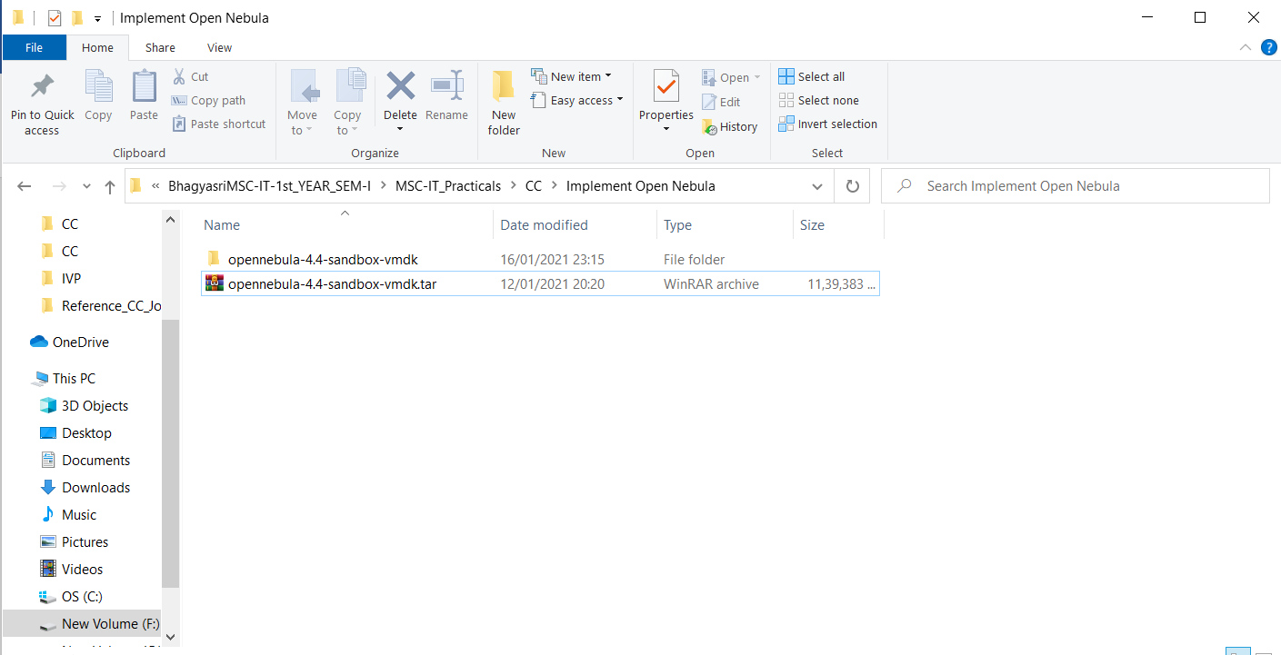

2) Start vSphere Client.

* Enter Static IP address (i.e., ESXi Sever address)
* Enter Username and Password. Click Login.

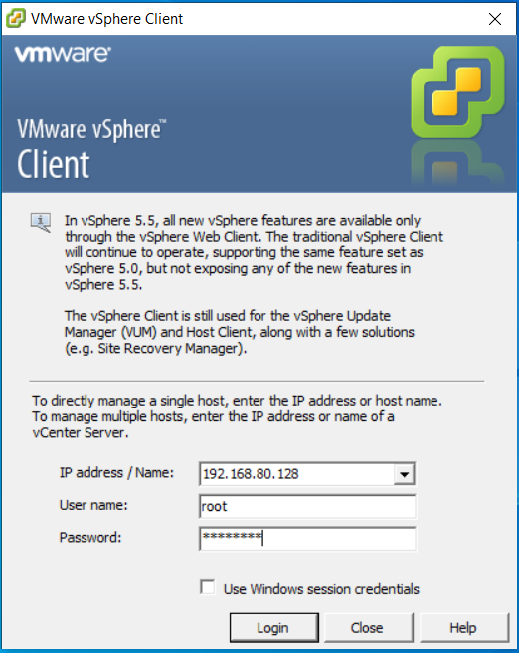

Click on ignore

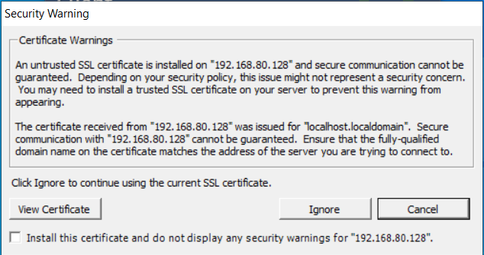

2) Go to Configuration tab select storage and right click on data store1 and select Browse Datastore. 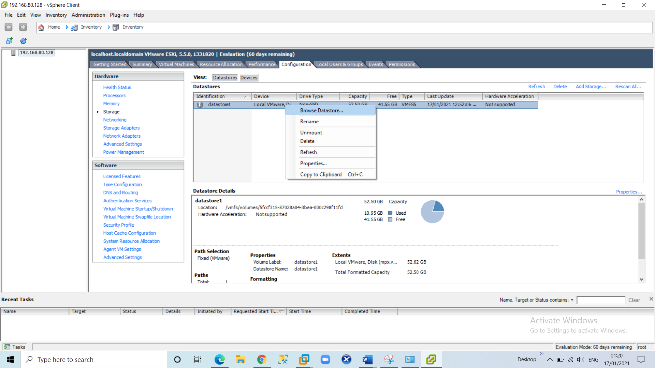

Click on “Upload files to this datastore” icon

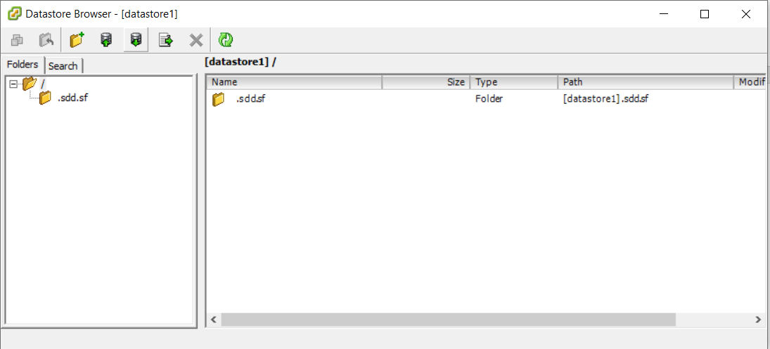

Click on “Upload File…”

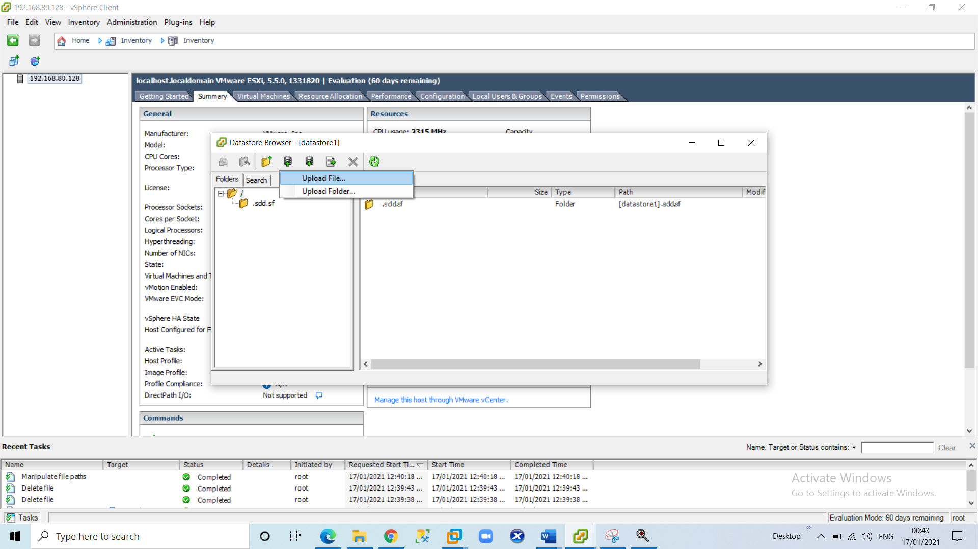

Go in this particular folder opennebula-4.4-sandbox-vmdk and select **disk.vmdk** file.

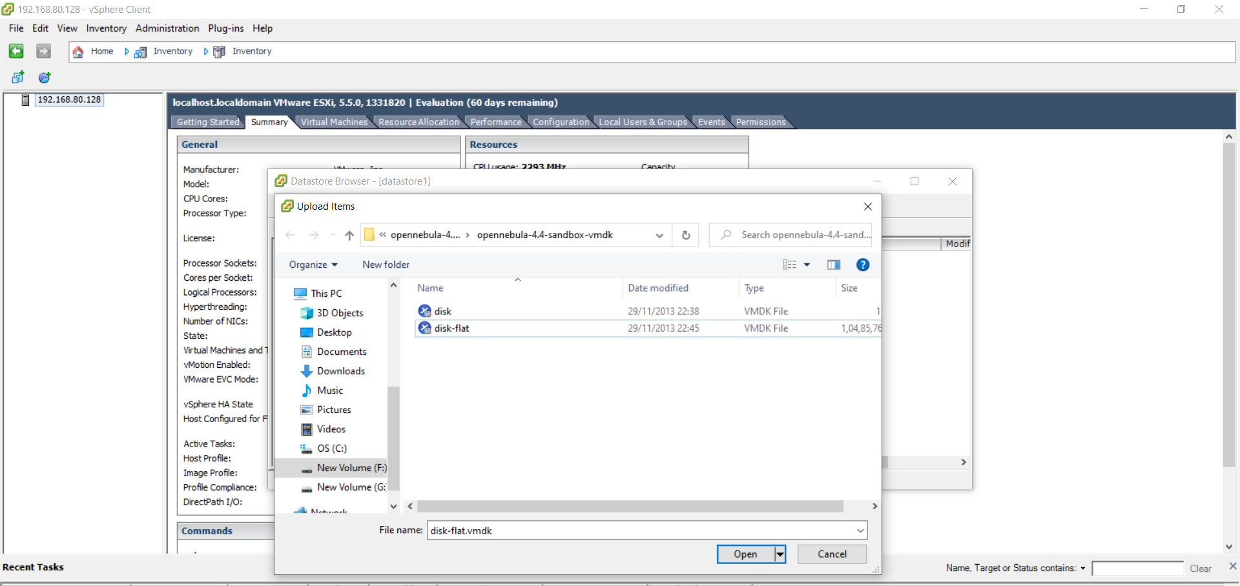

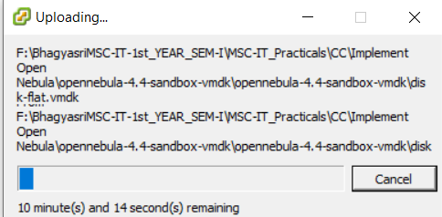

The disk.vmdk file upload is complete.

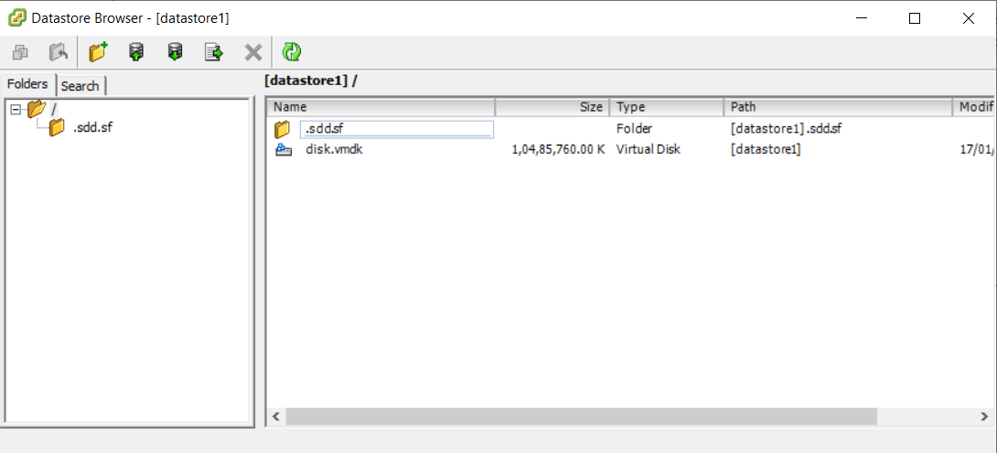

3) Create a new virtual machine. On the VI client click on the (new virtual machine) icon.

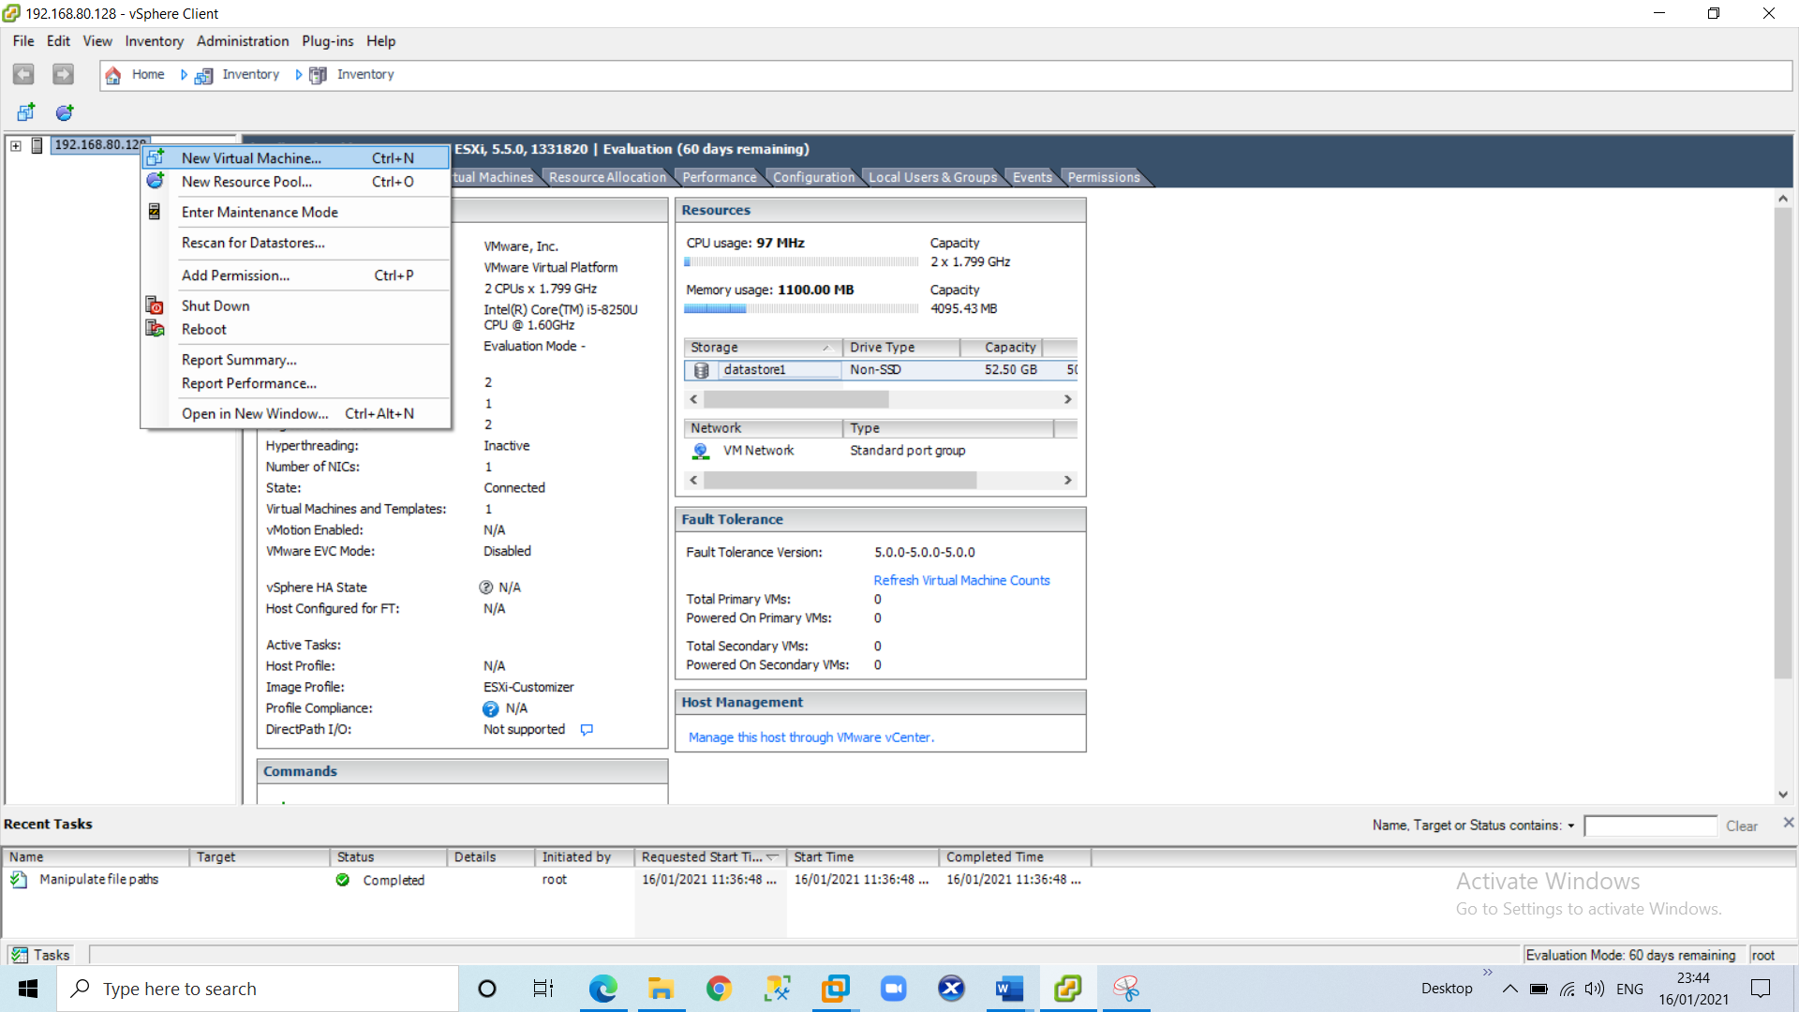

4) Select custom virtual machine and click on next.

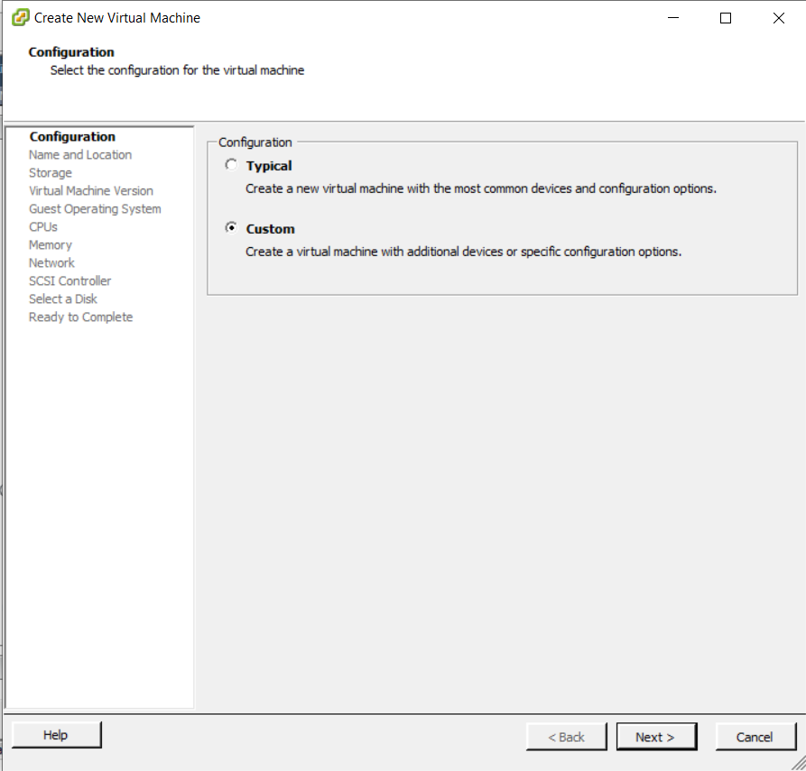

**Name:** Opennebula-sandbox and click on next.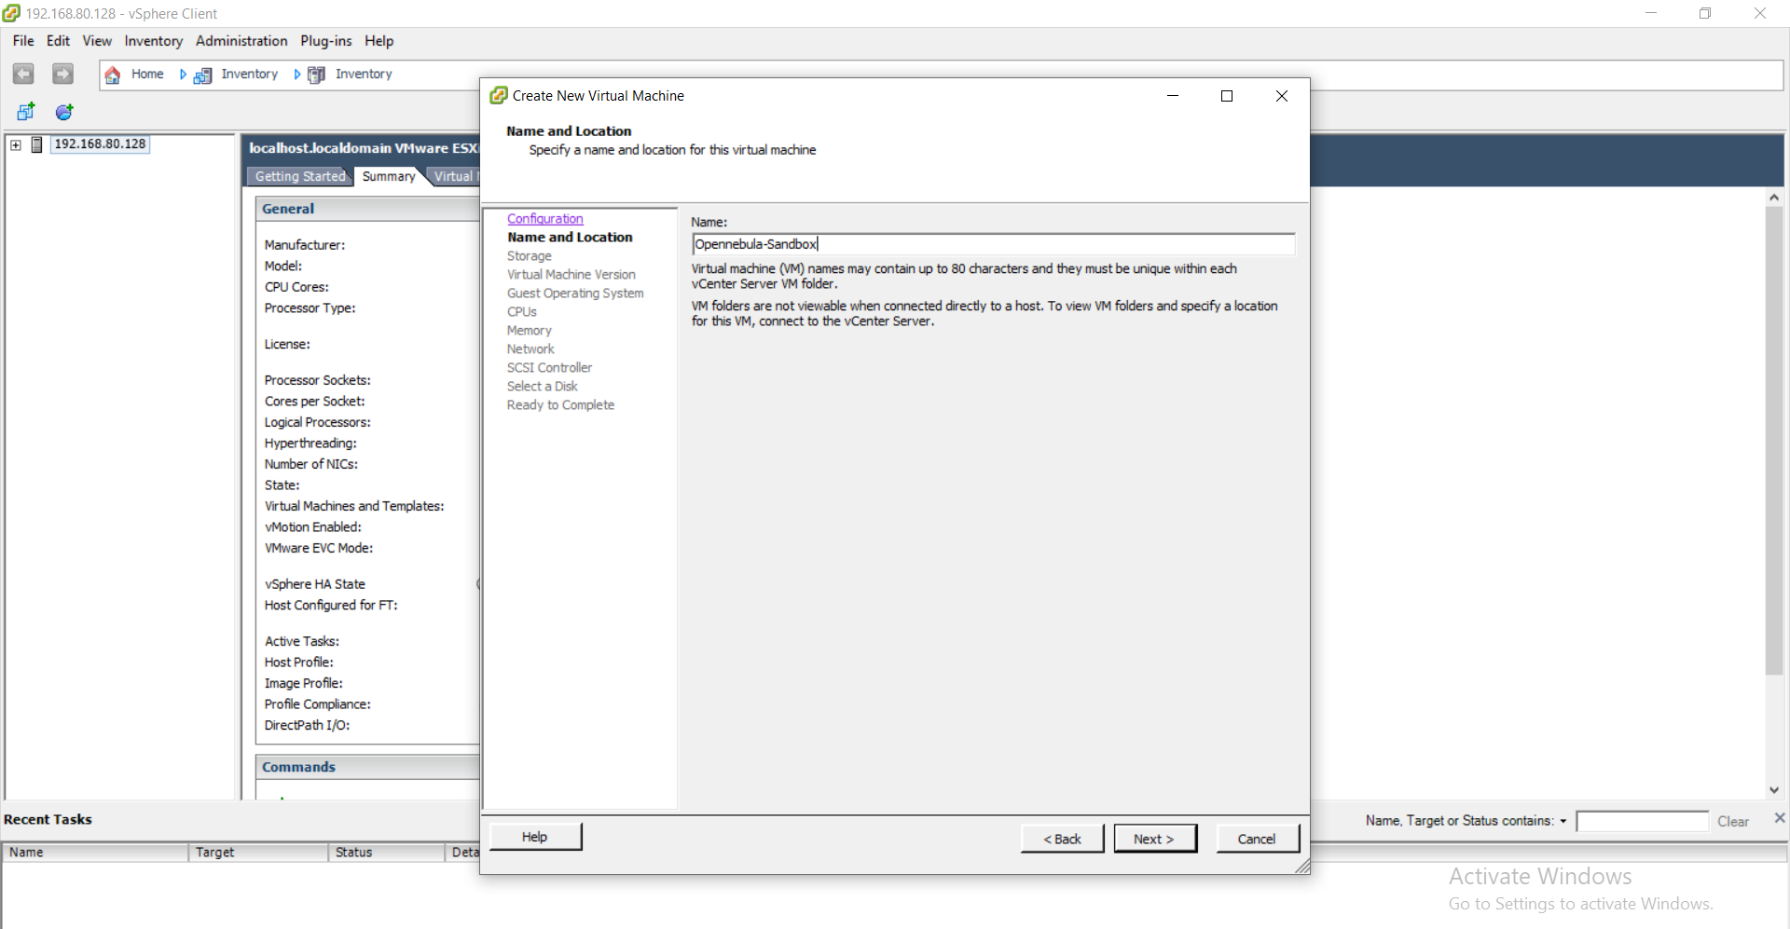

Select the same data store as in the screen and click on next.

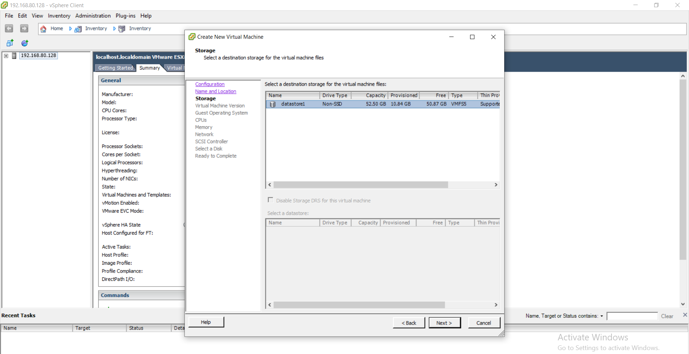

Select virtual machine version 8 and click on next.

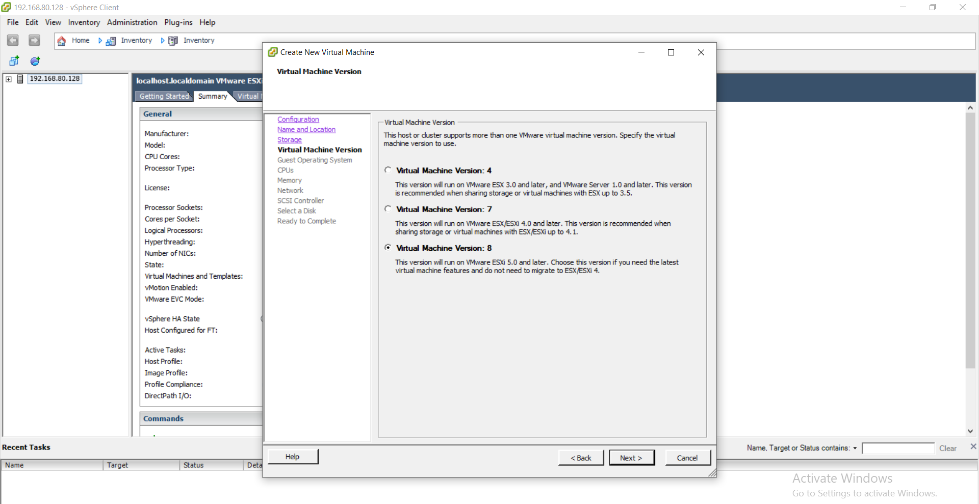

Select Linux option-->and then select CentOS 4/5/6(64-bit) and click on next.

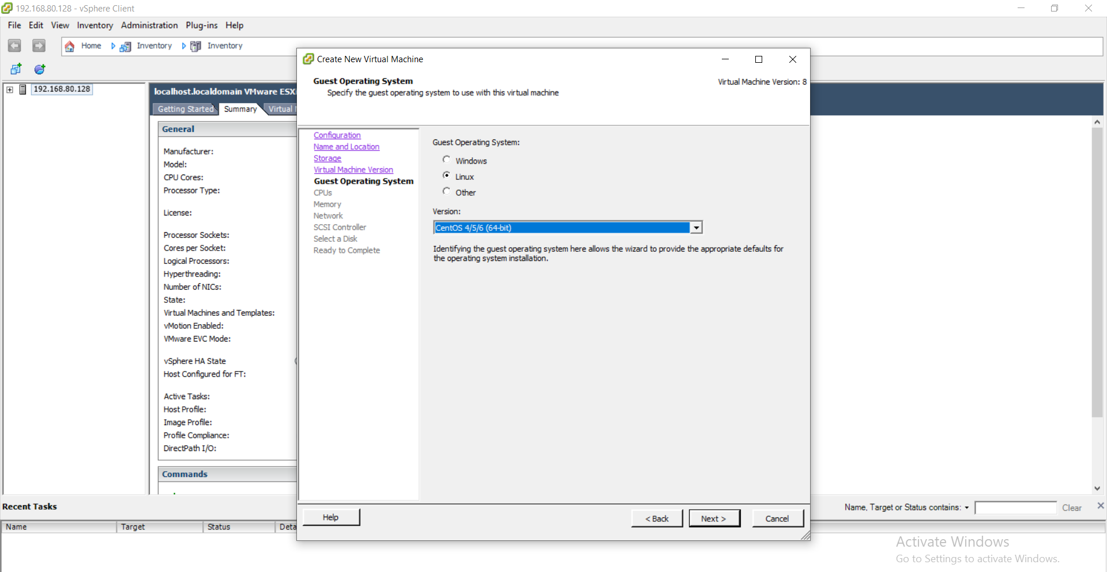

CPUs: Accept the defaults and click next.

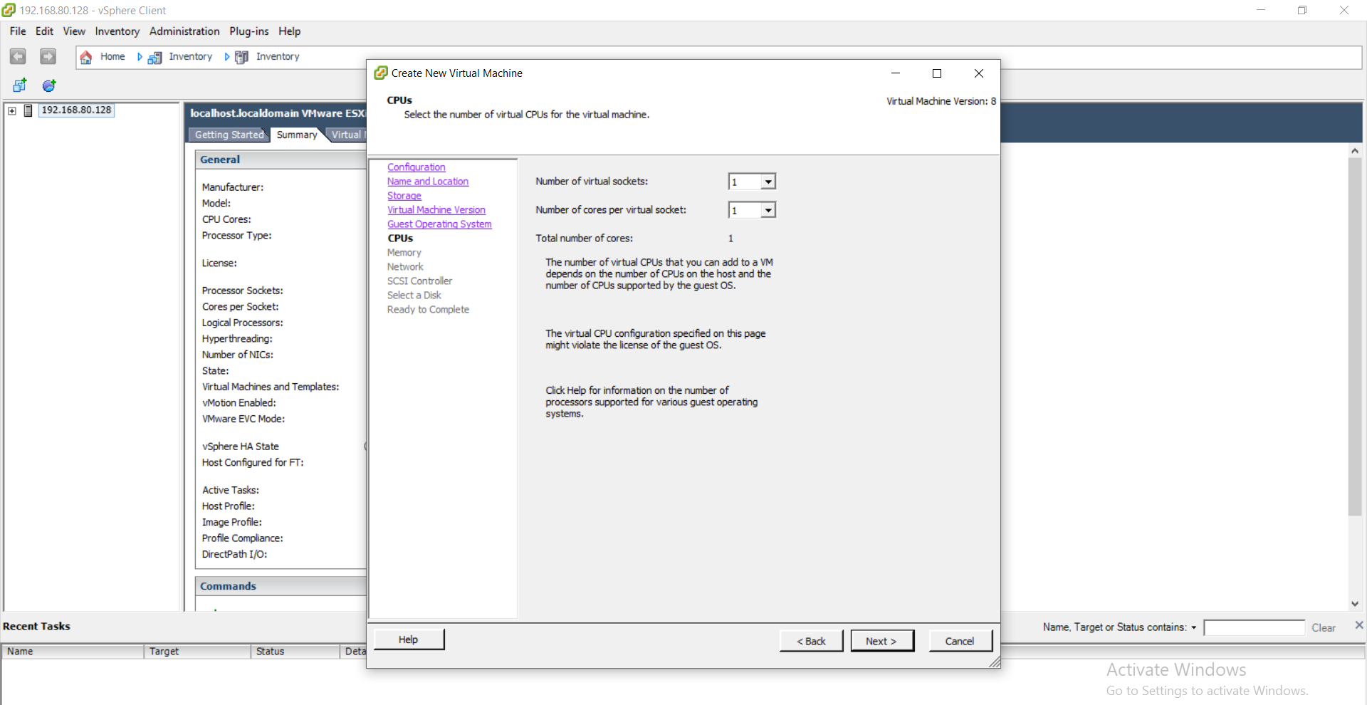

Select memory as 1 GB and click next

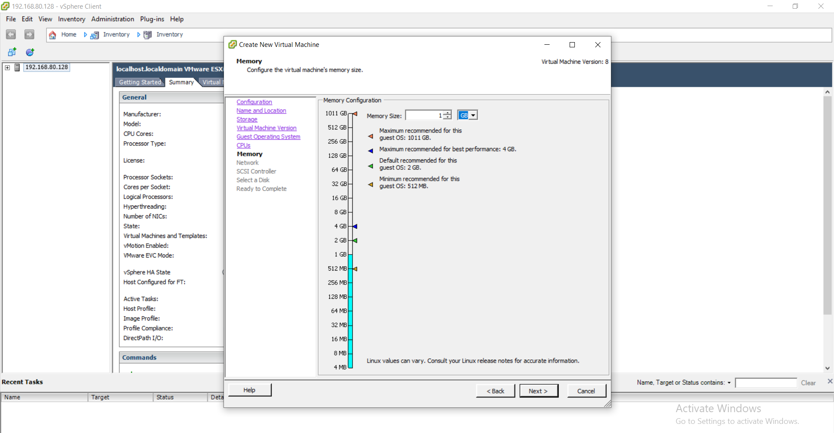

Select it as default and click next

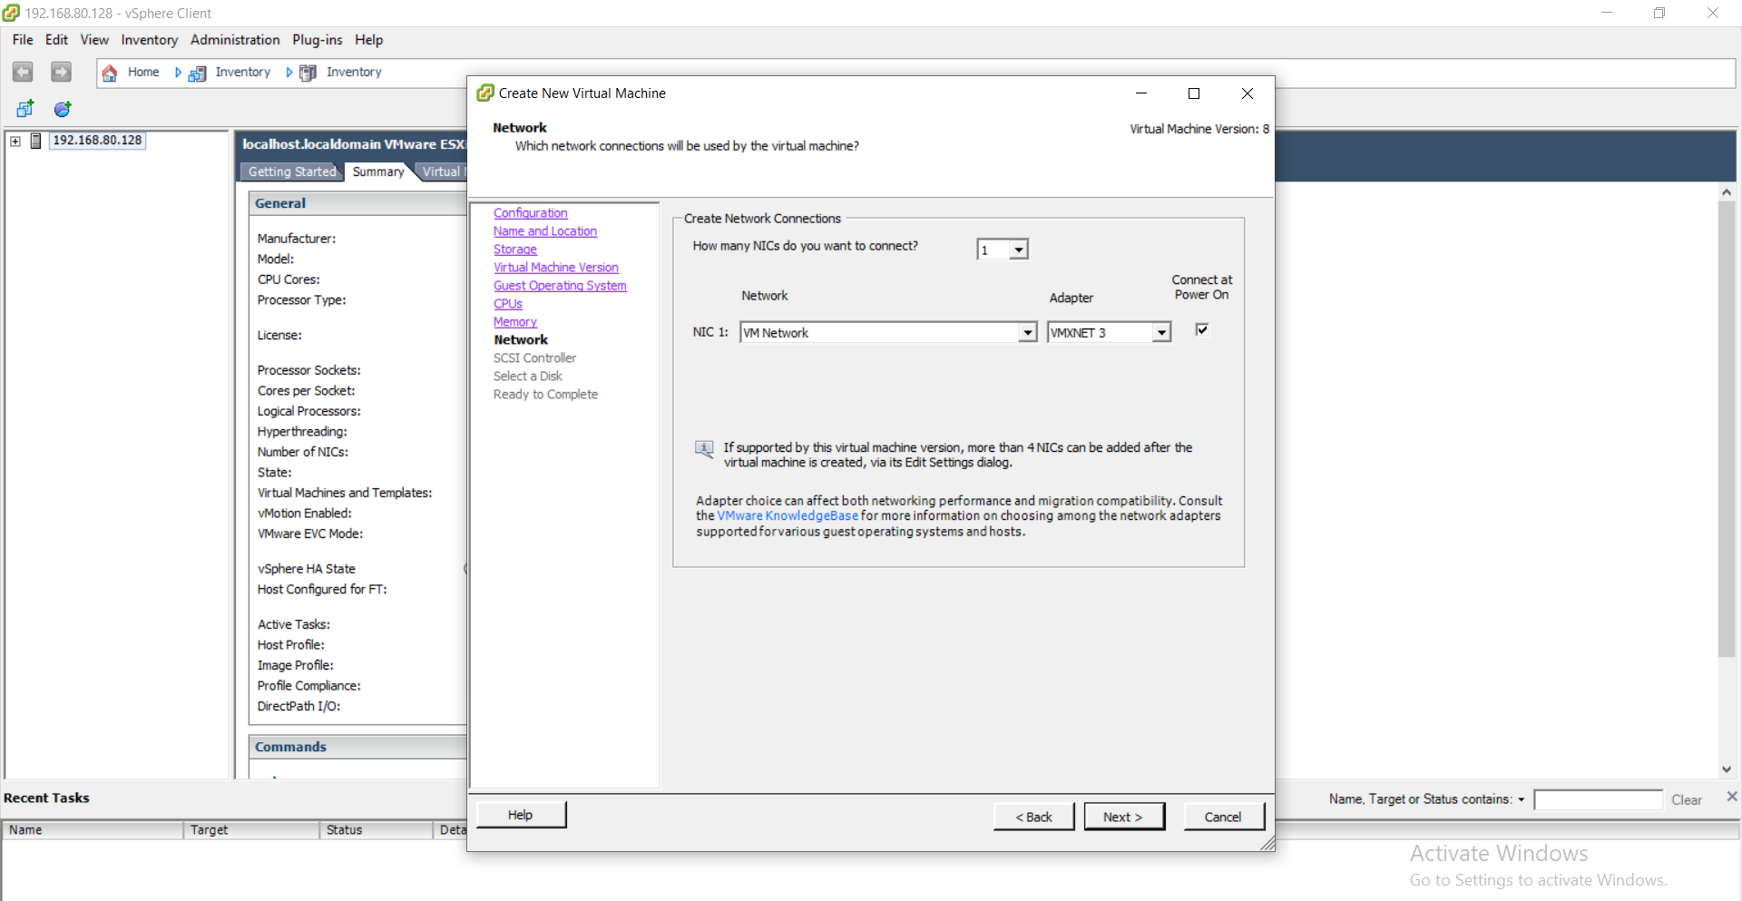

In the SCSI controller select as VMware Paravirtual and click next.

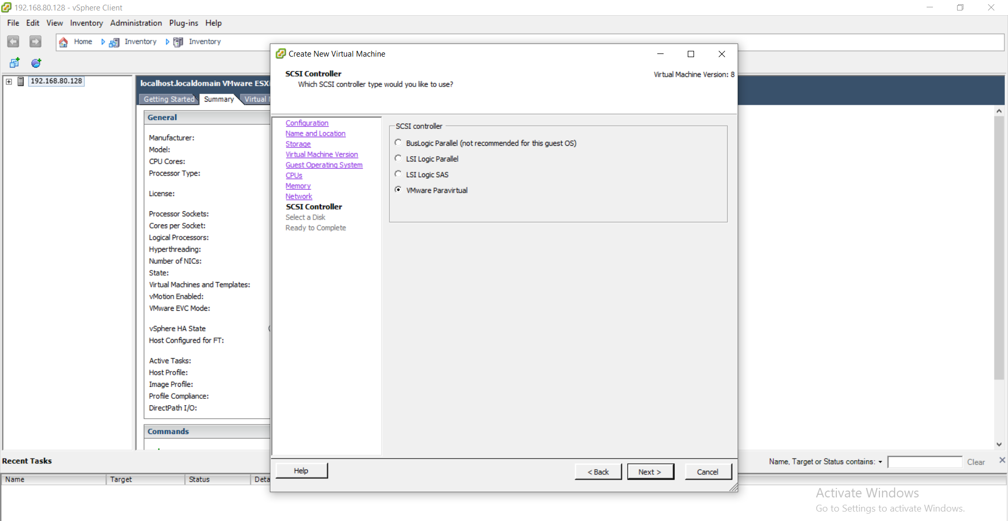

Select disk --> use an existing virtual disk and click next.

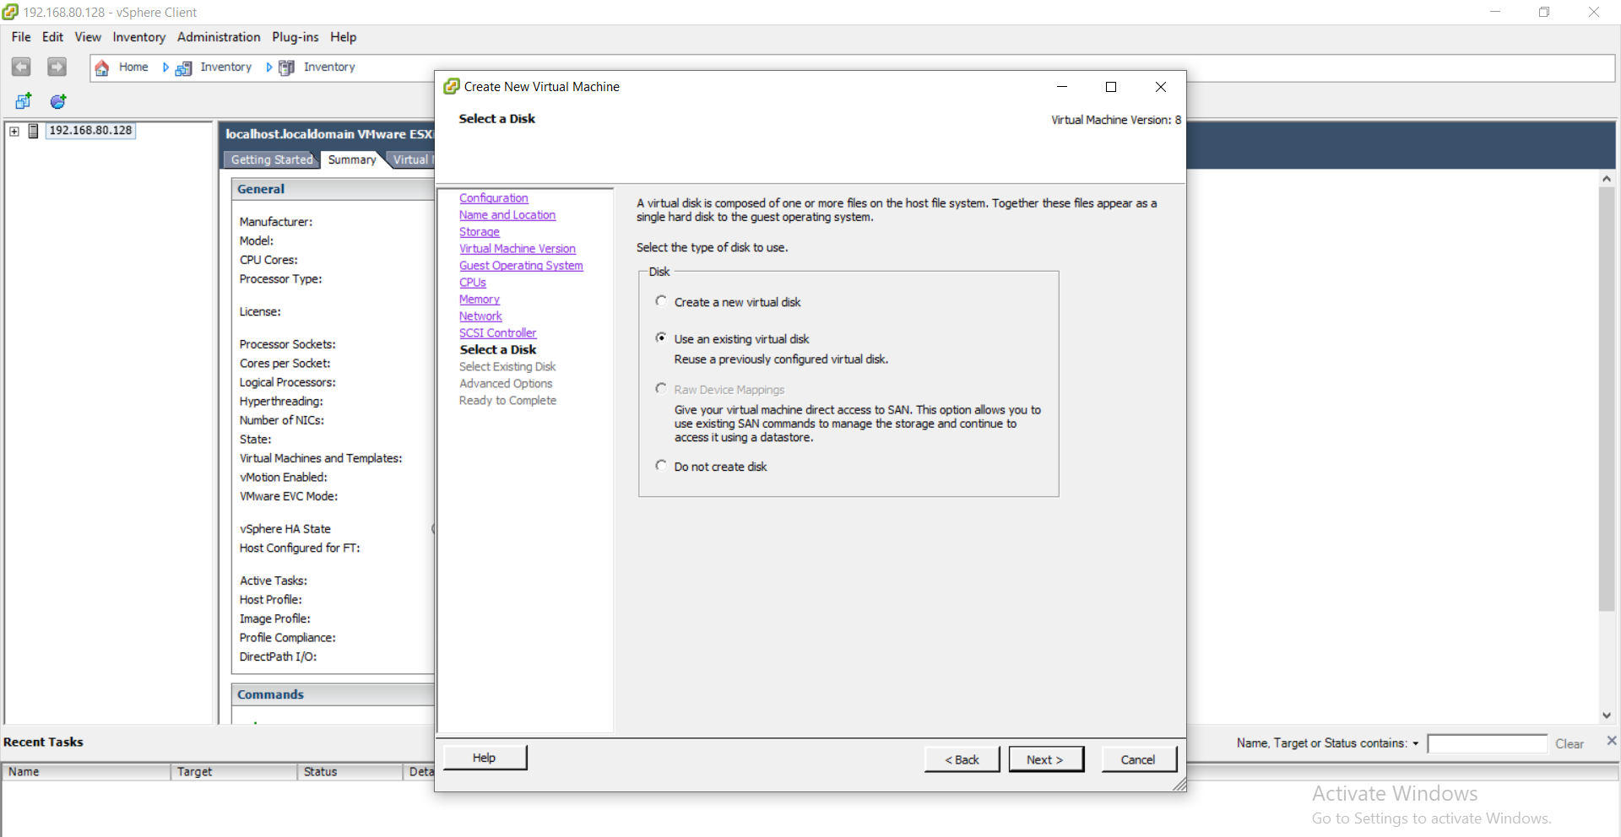

Click on browse and select data store1

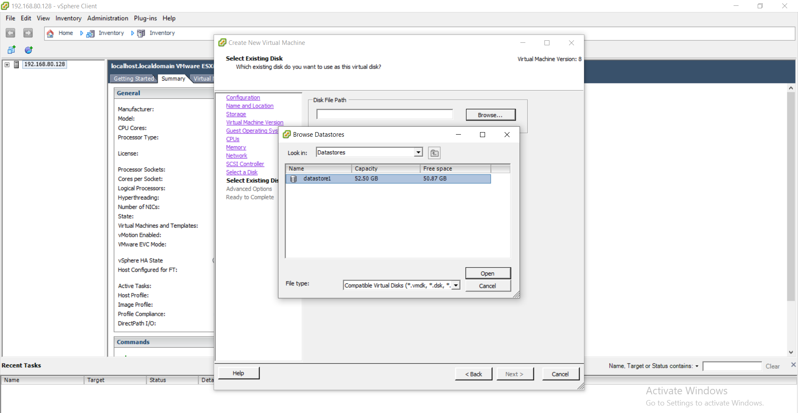

Double click on datastore1 -- You will get disk.vmdk file & click on OK

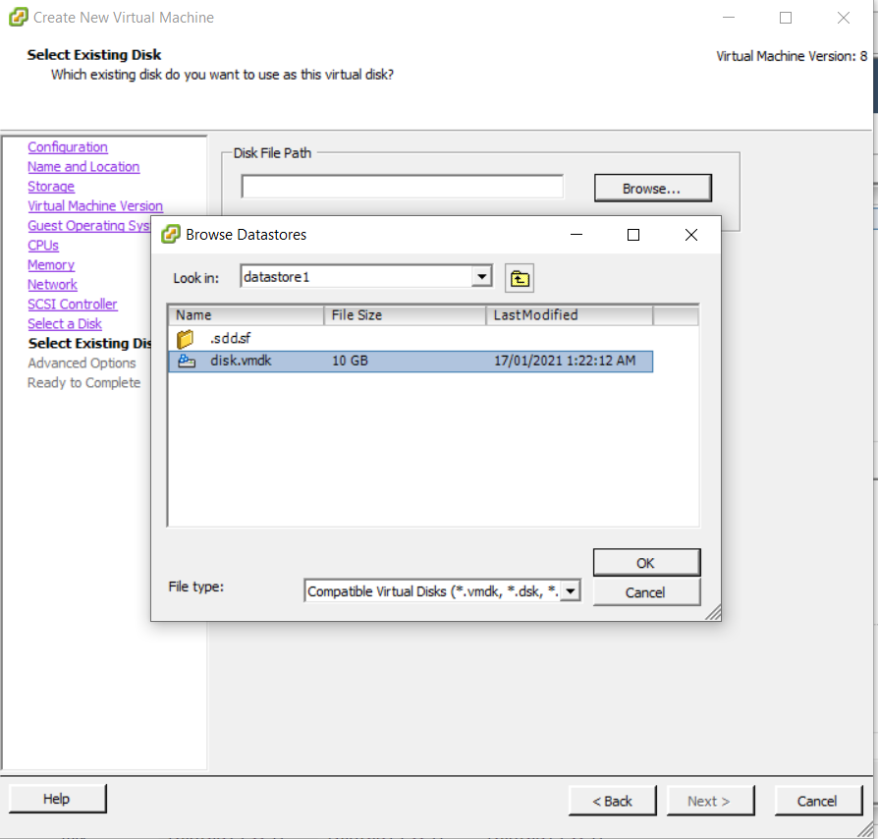

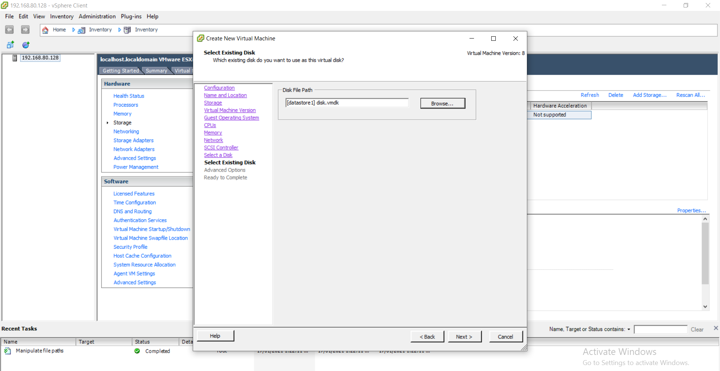

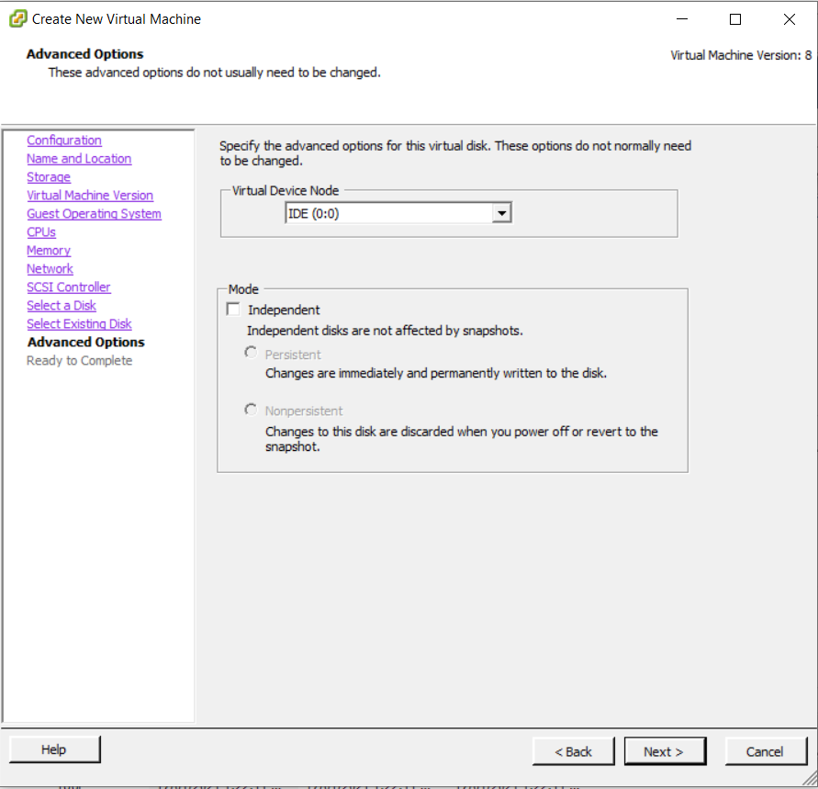

Click on Next.

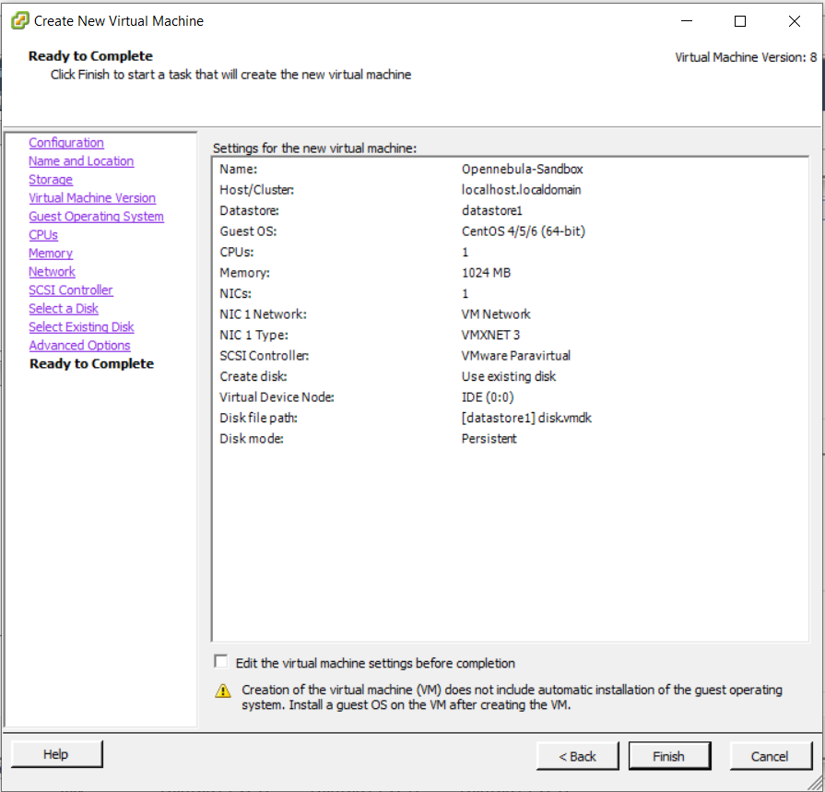

Click on Finish.

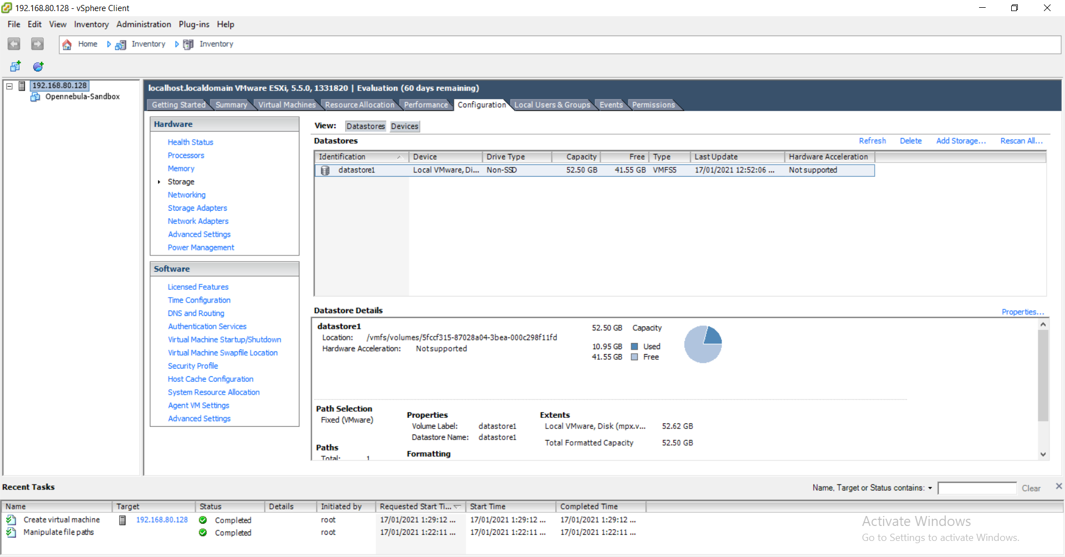

Power on the virtual machine

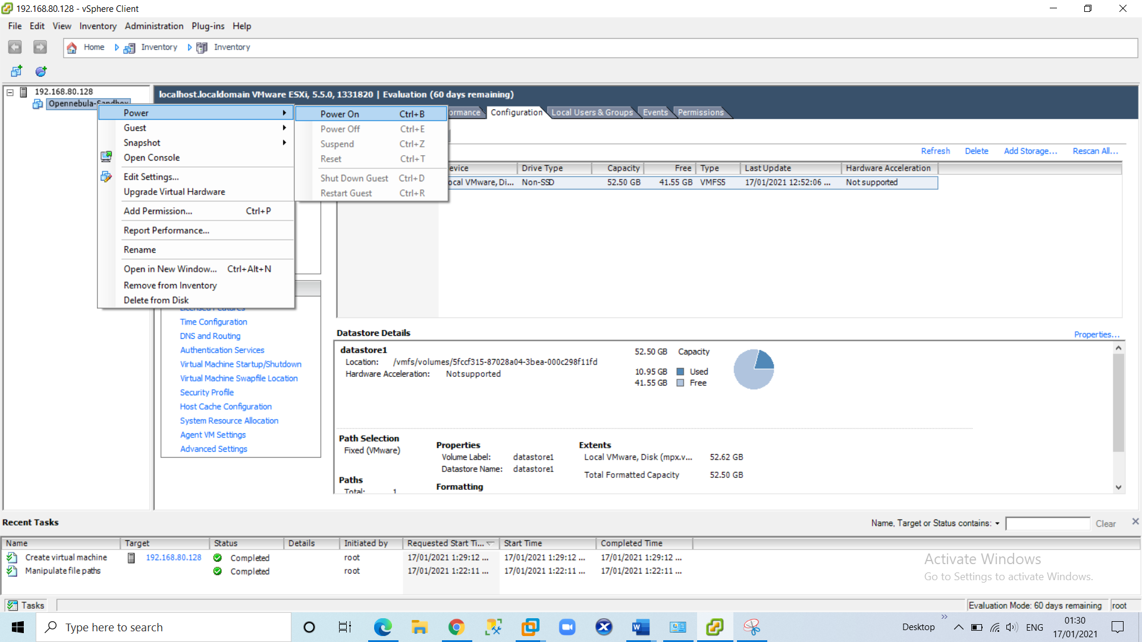

Click on console tab

At this point the VM will be running. Wait until you see a login prompt in the VI client console that says “one-sandbox login”

You can log in into the VM using the following information:

Login : root

Password : opennebula

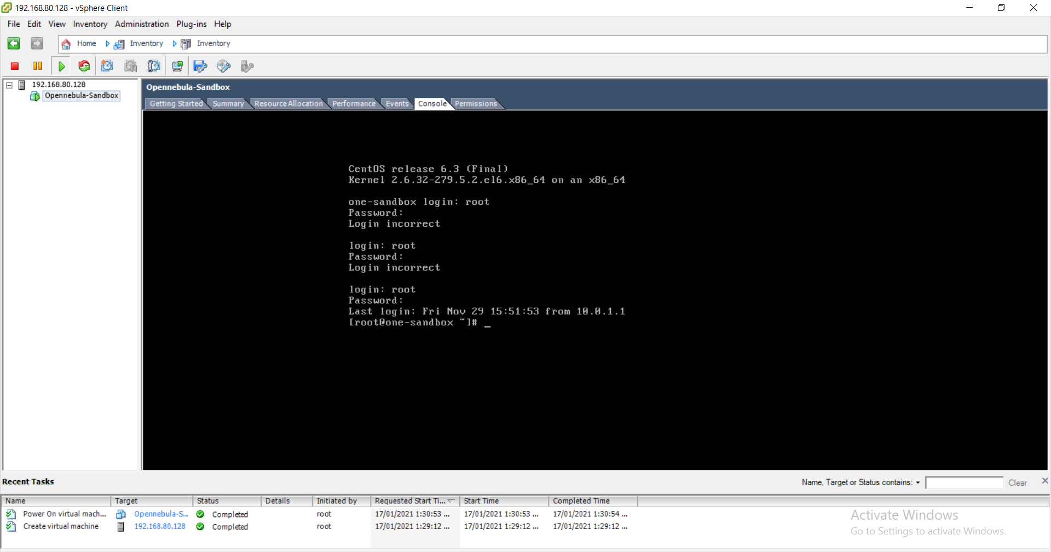

5) Type ifconfig eth0 command to check ip address of linux centos machine

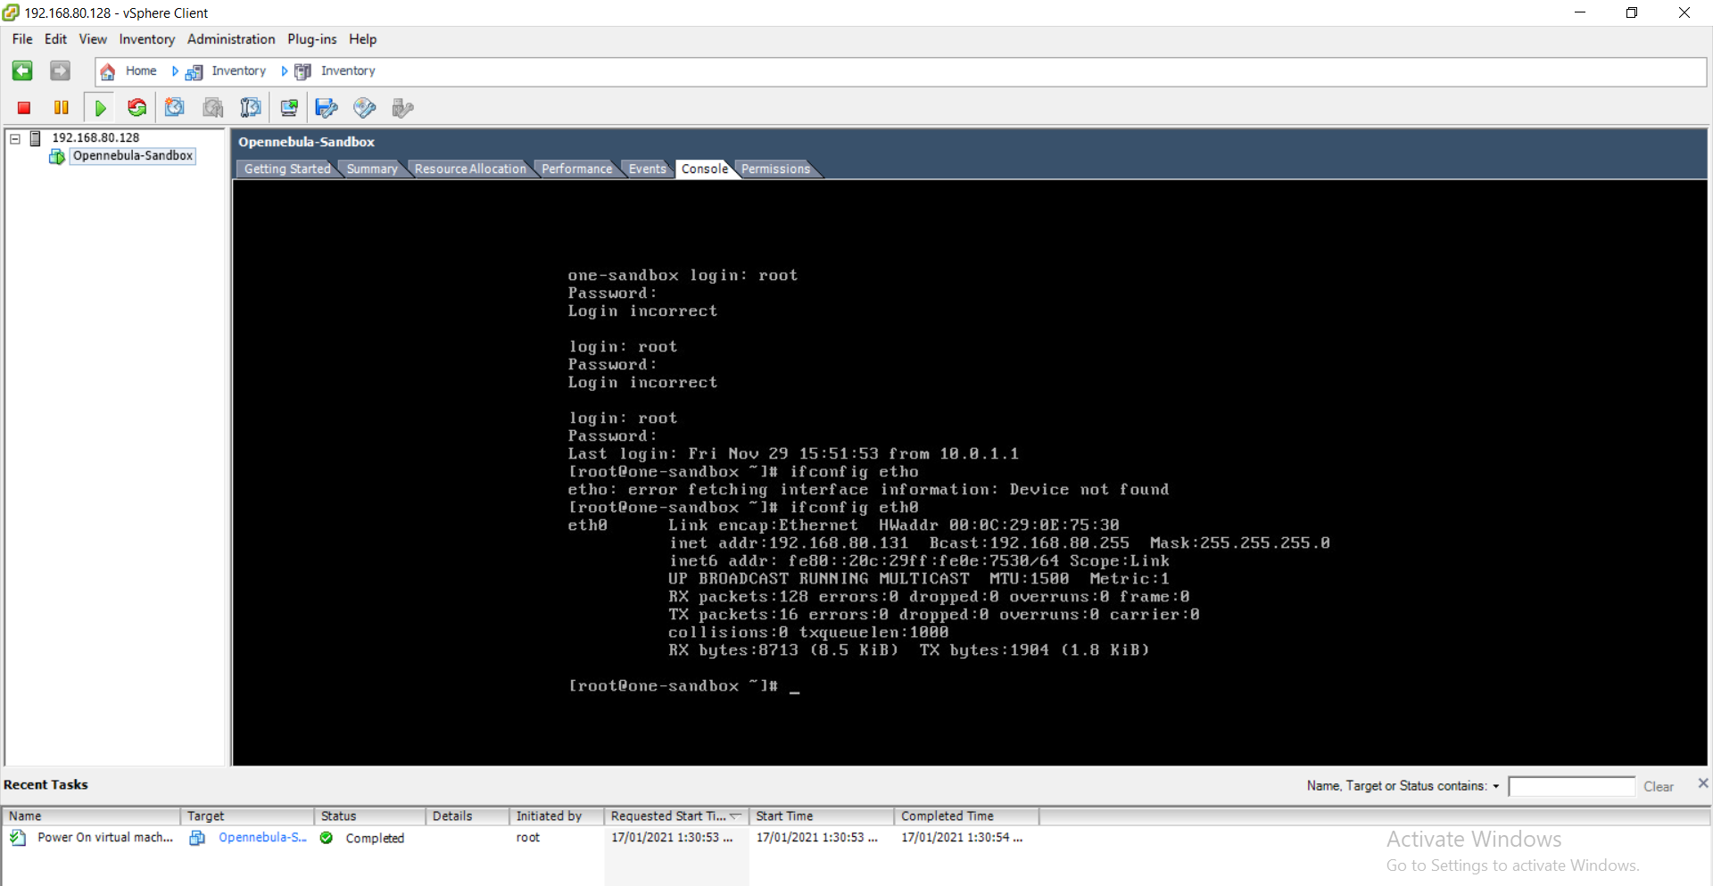

Since ip address of openebulla is 192.168.80.131 Now try to ping 192.168.80.131 openebulla on host OS

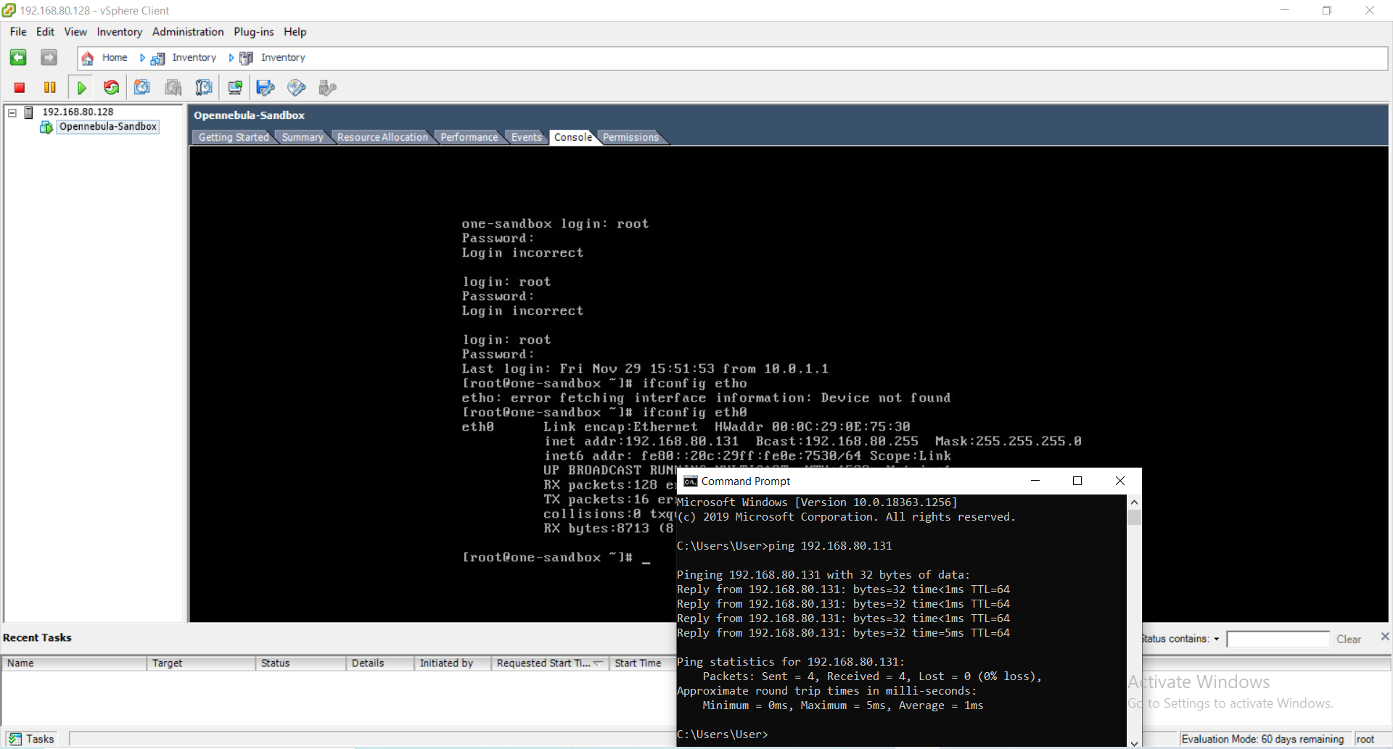

Go to Browser copy the http path for the above ip address of open nebula(E.g. http://192.168.80.131:9869) and paste it.

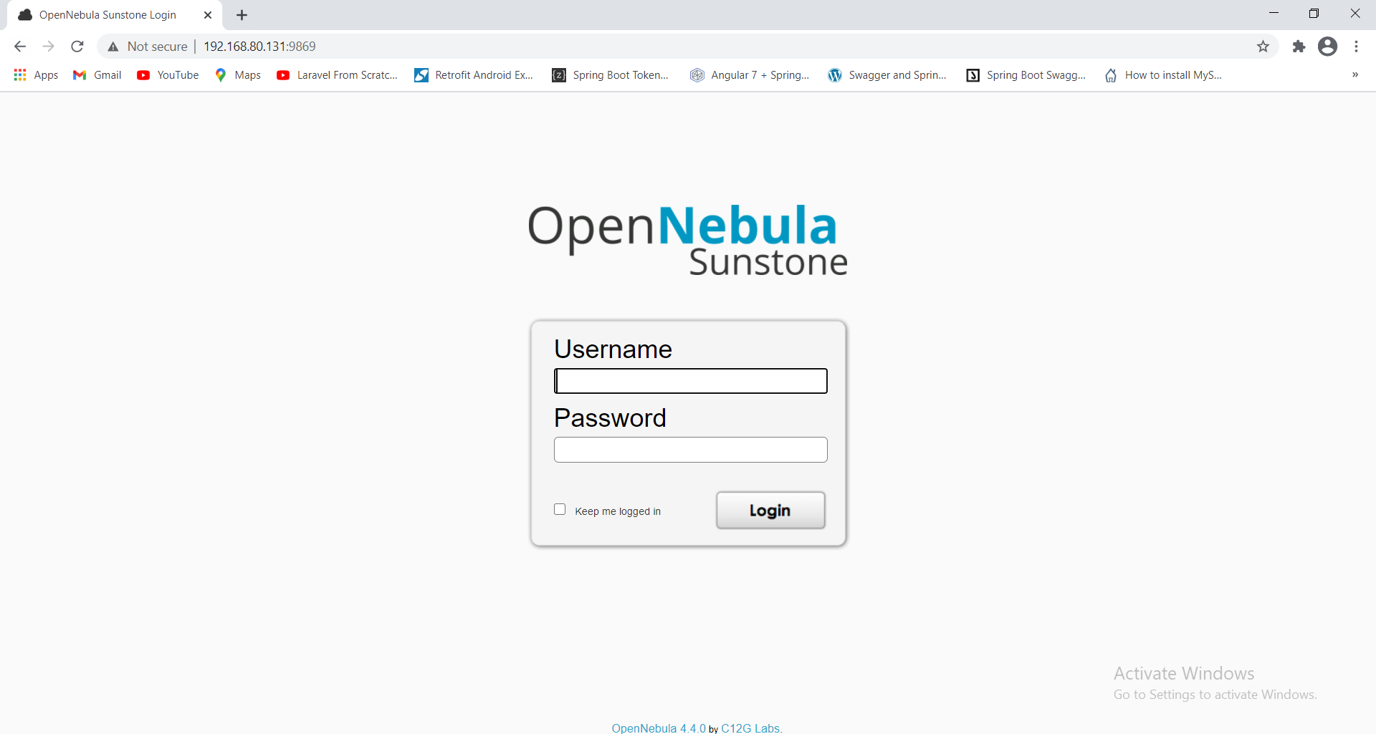

type username : oneadmin

password : opennebula

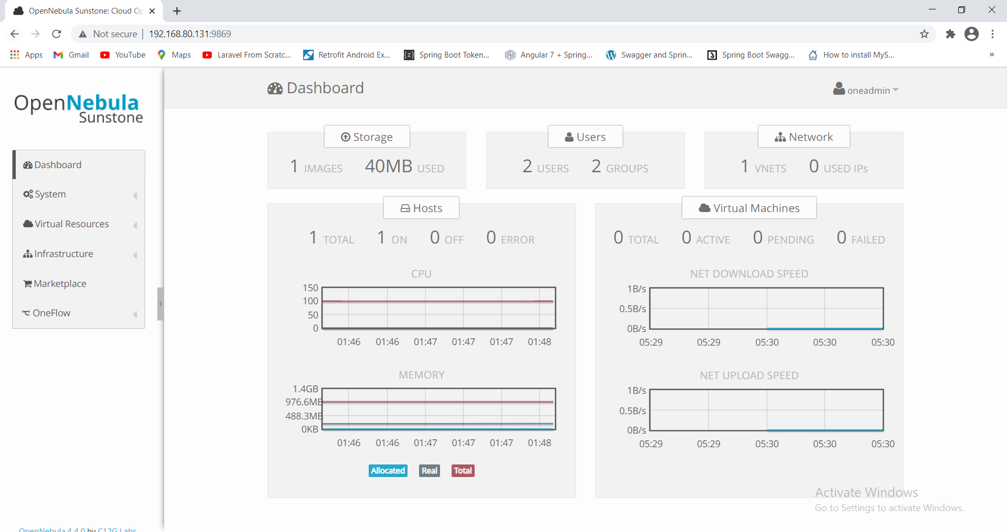

Now we will create Datastore

click on "create" and type name “test-12” and click on "create"

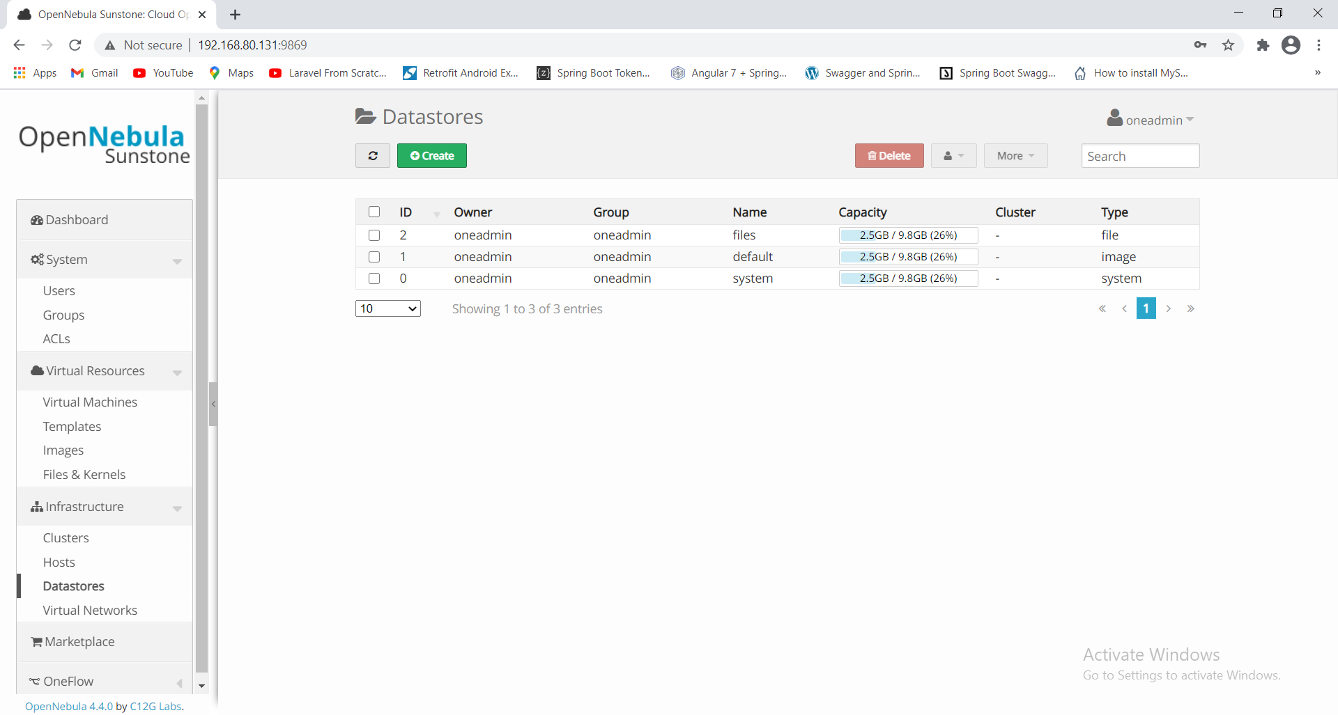

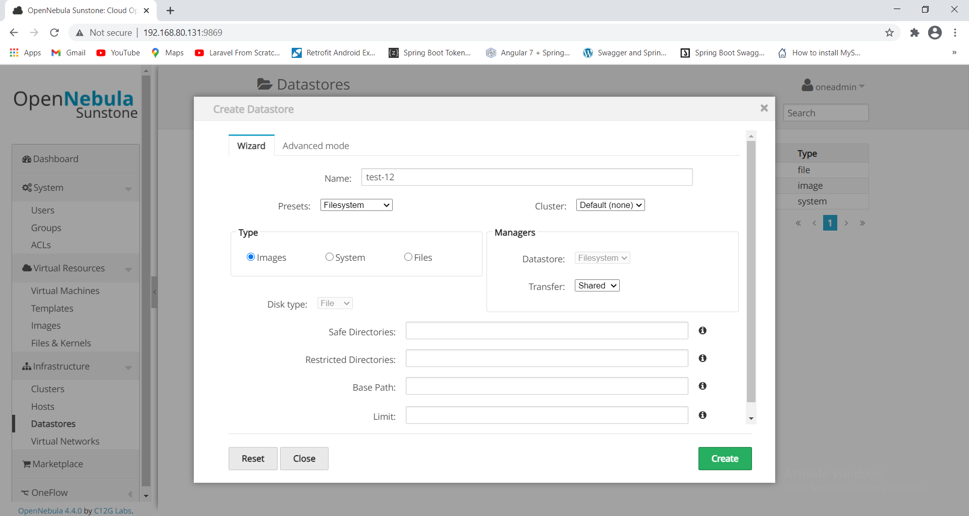

DATASTORE is created

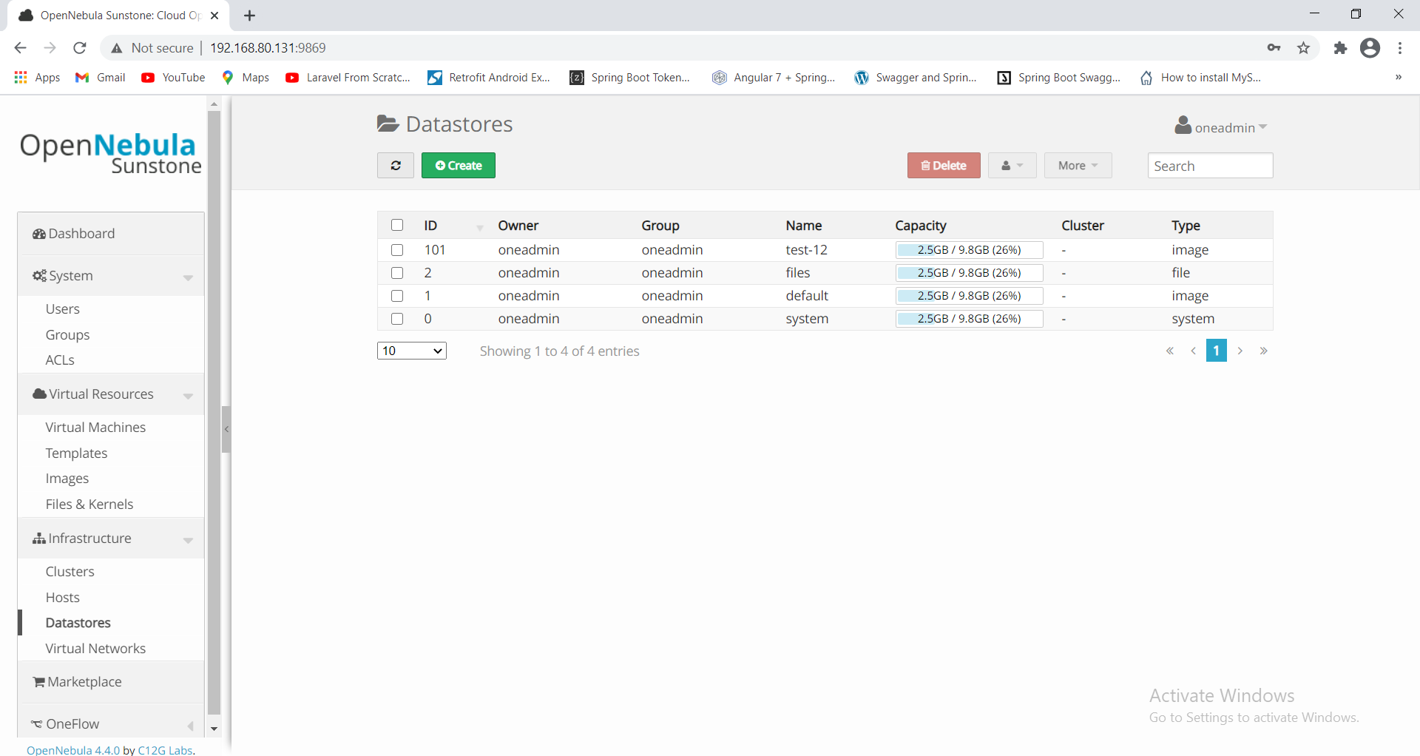

Now we will create "Virtual Network"

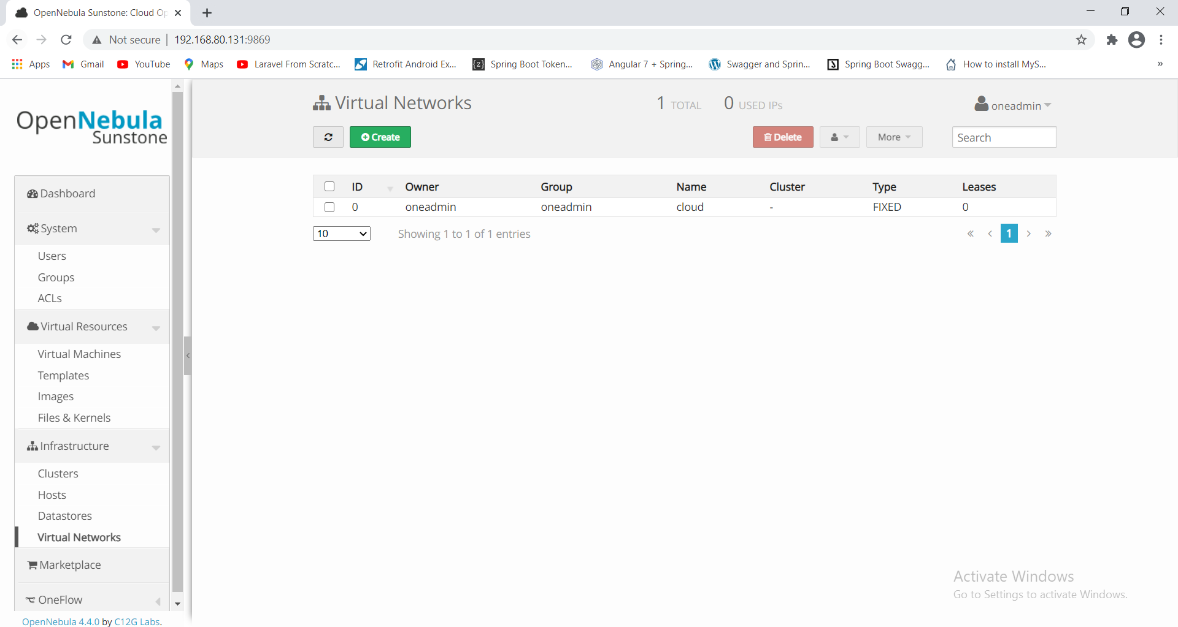

click on "Create" provide name as "local_test" click on Fixed Network

provide ip address in range "192.168.1.100" to "192.168.1.106" and also provide Bridge name:"br0" and give **Group** permission for **Use**

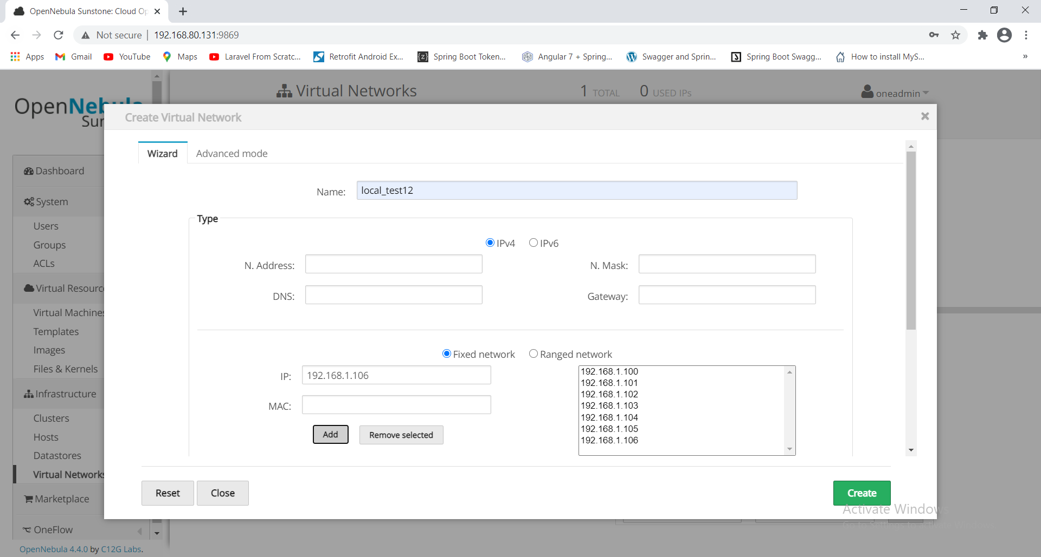

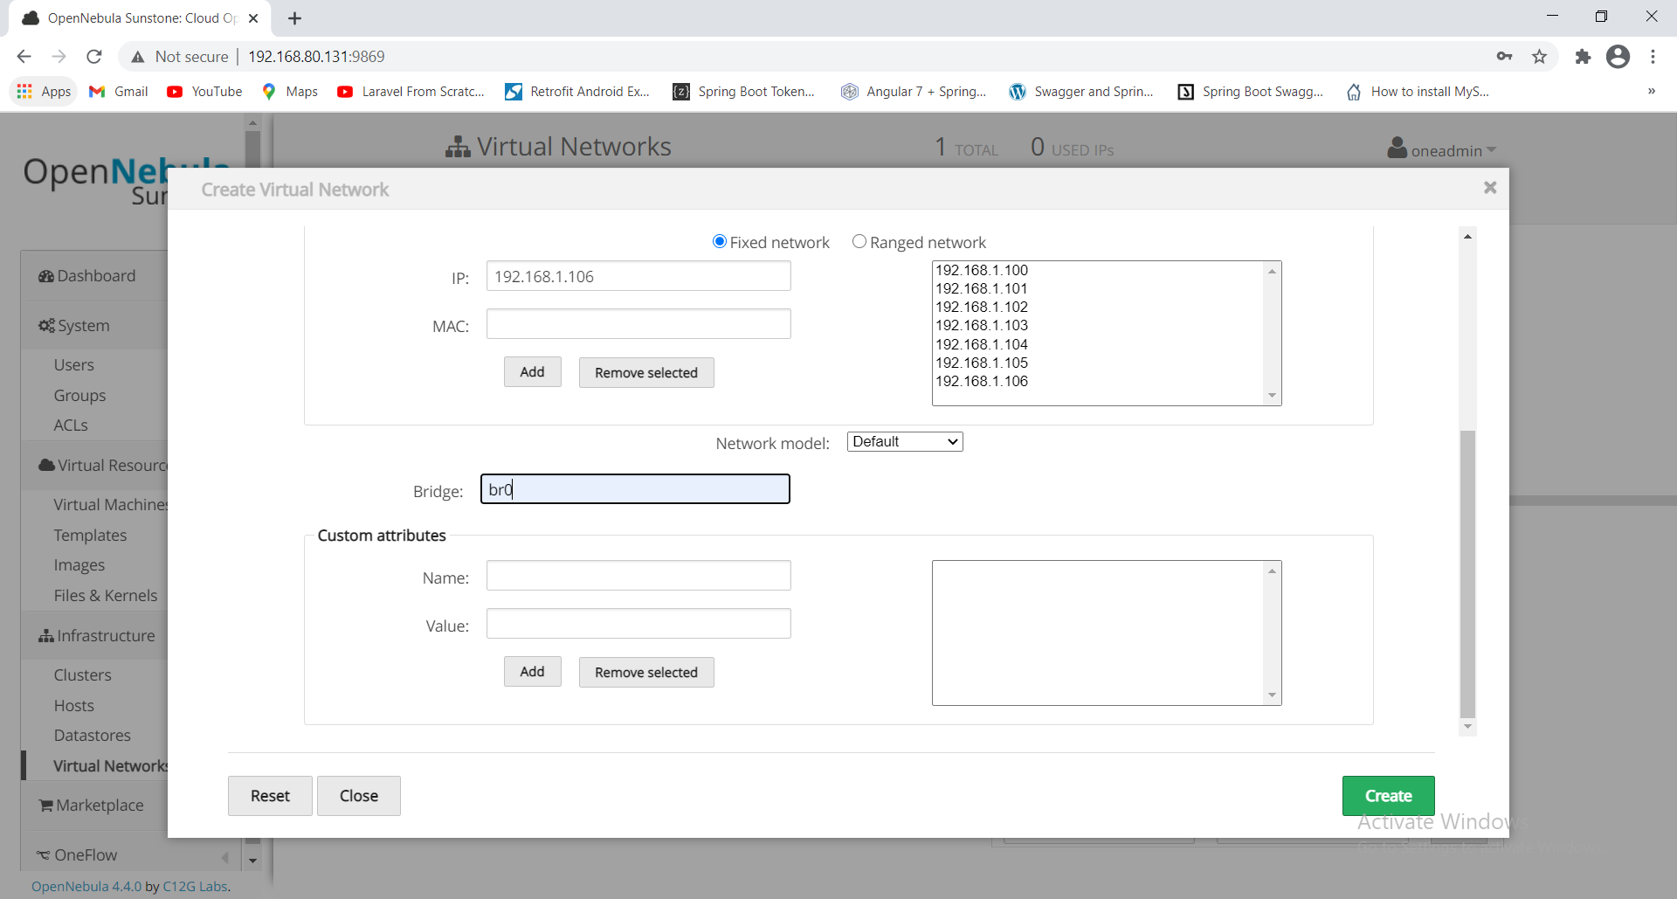

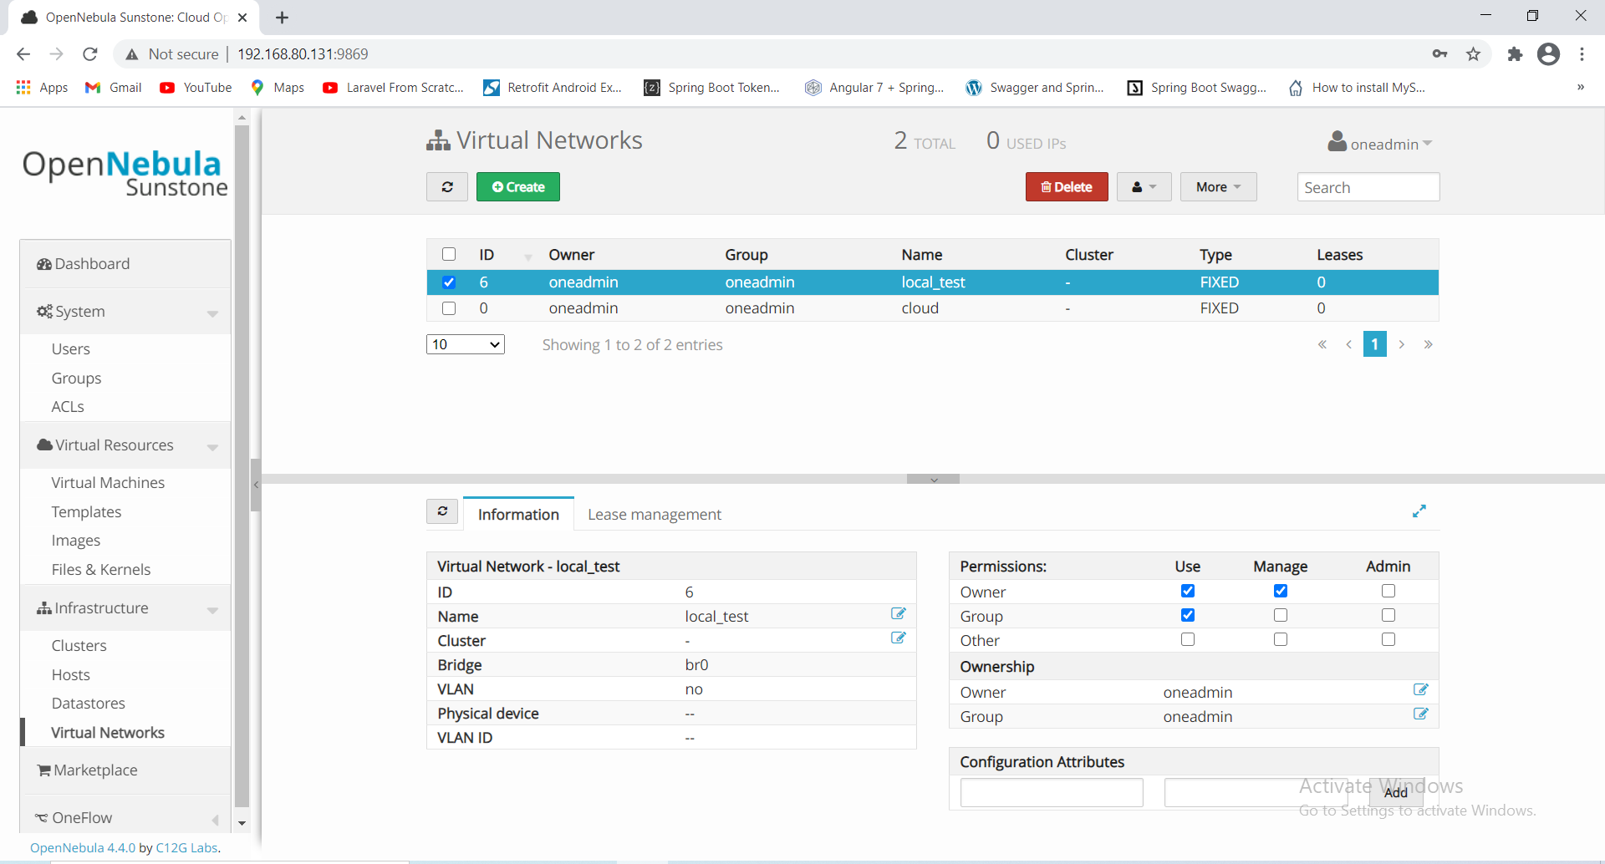

create new user name: root

password : opennebula

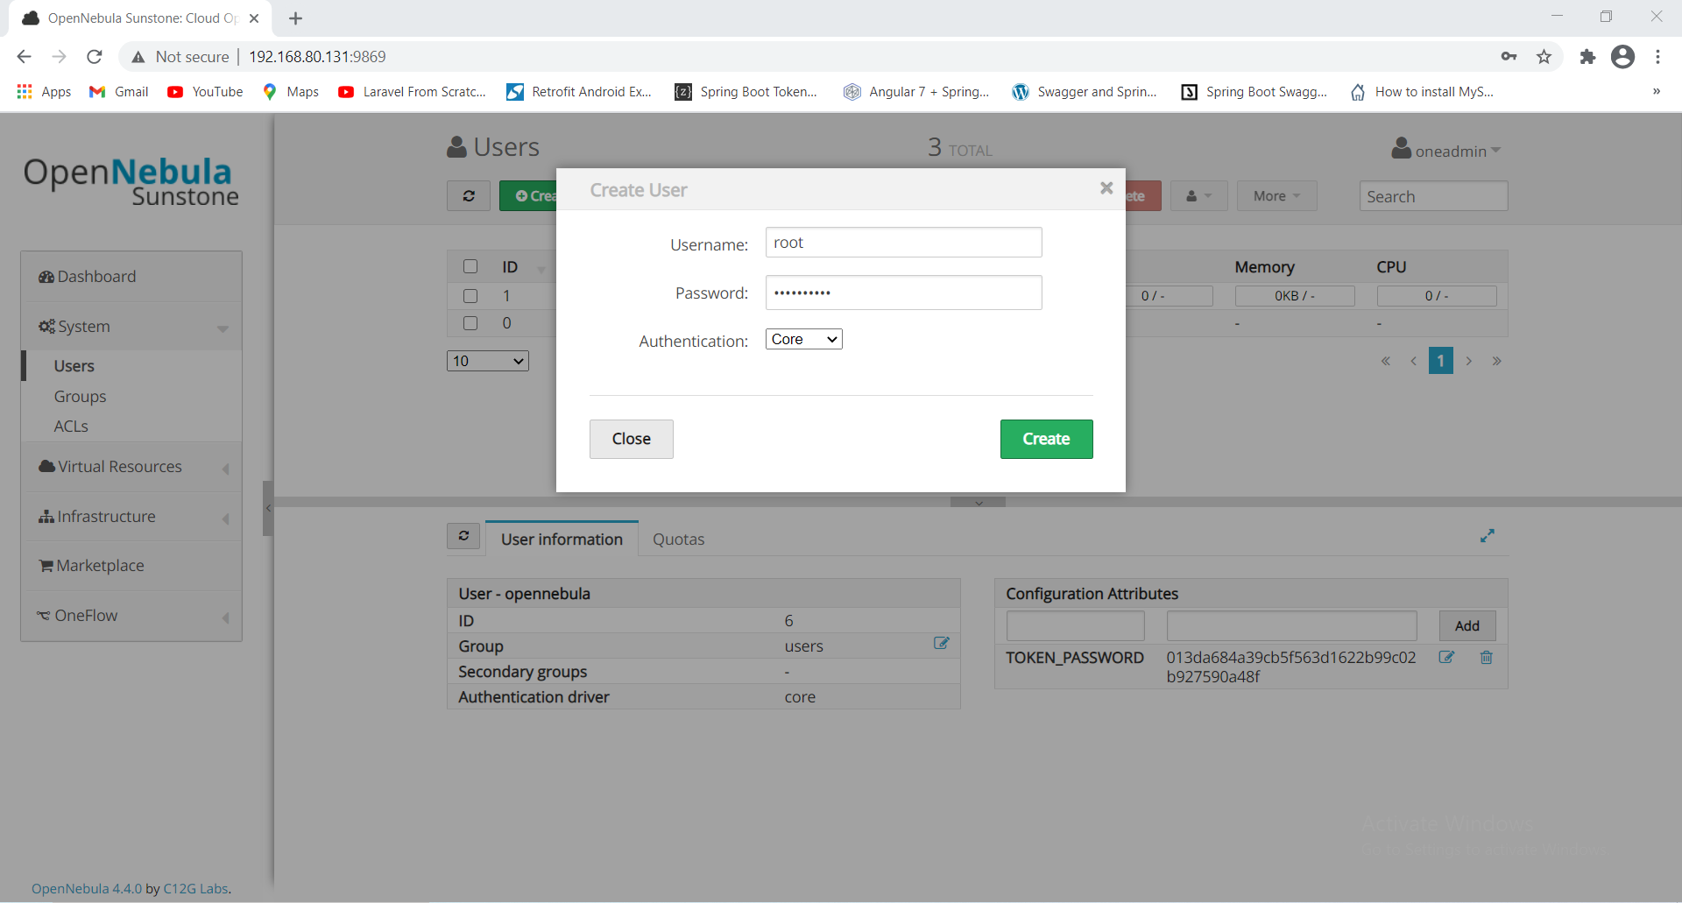

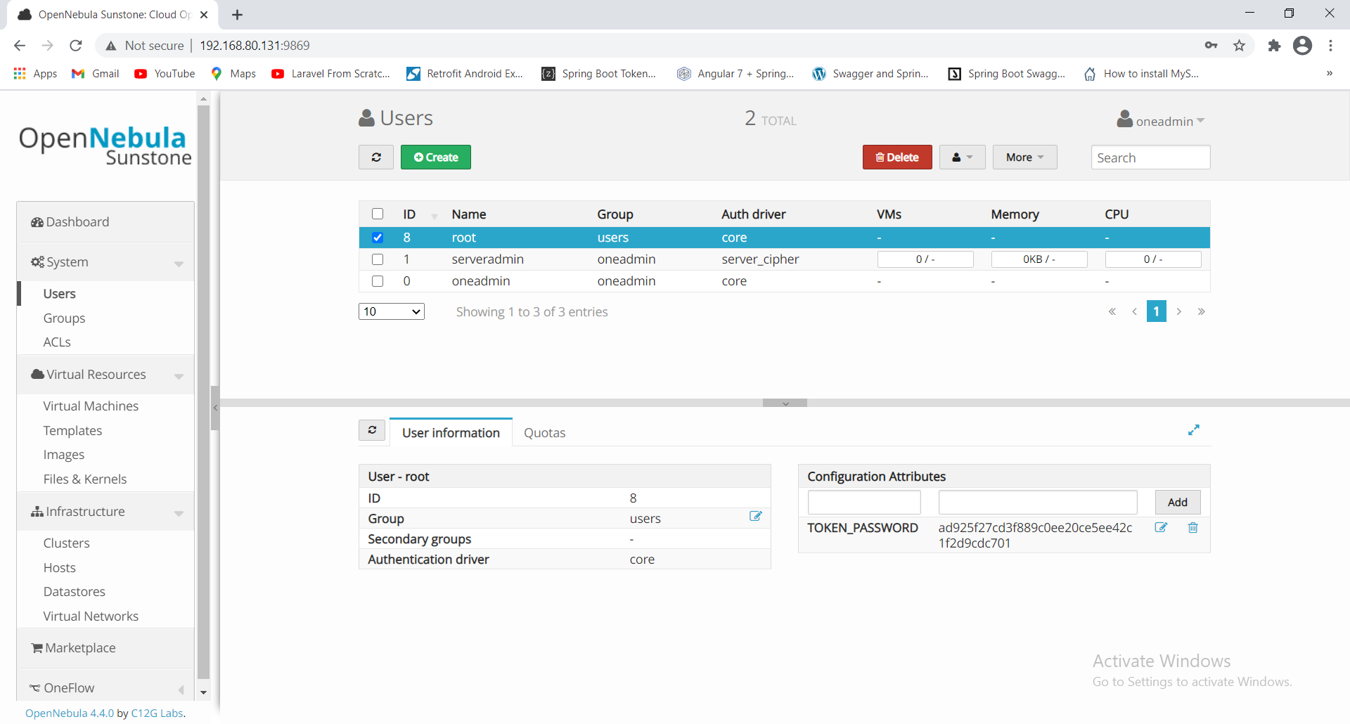

now login again as username : root

password : opennebula

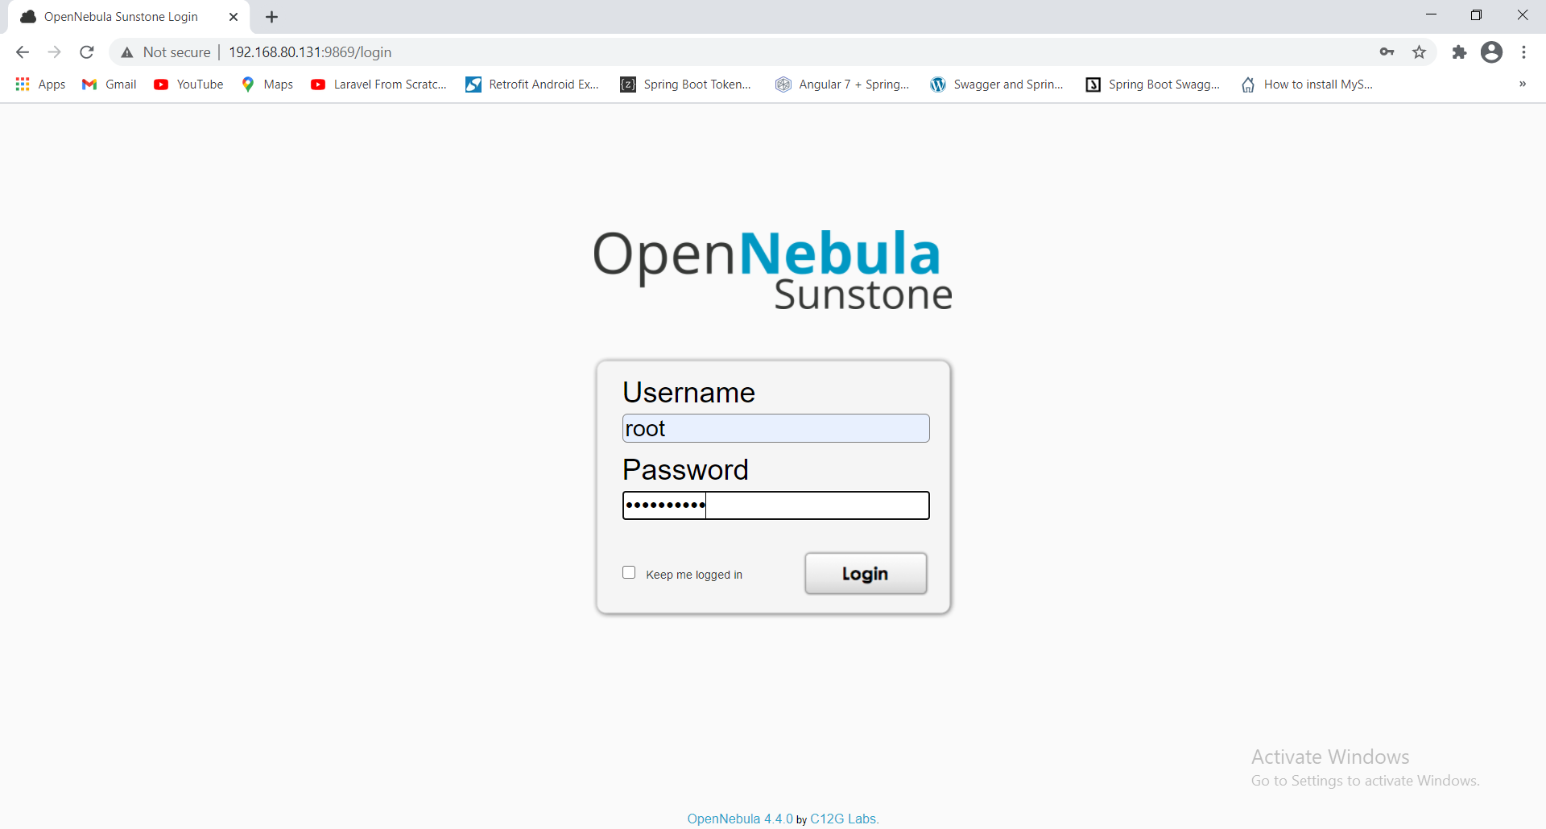

click on "Virtual Resources" and images

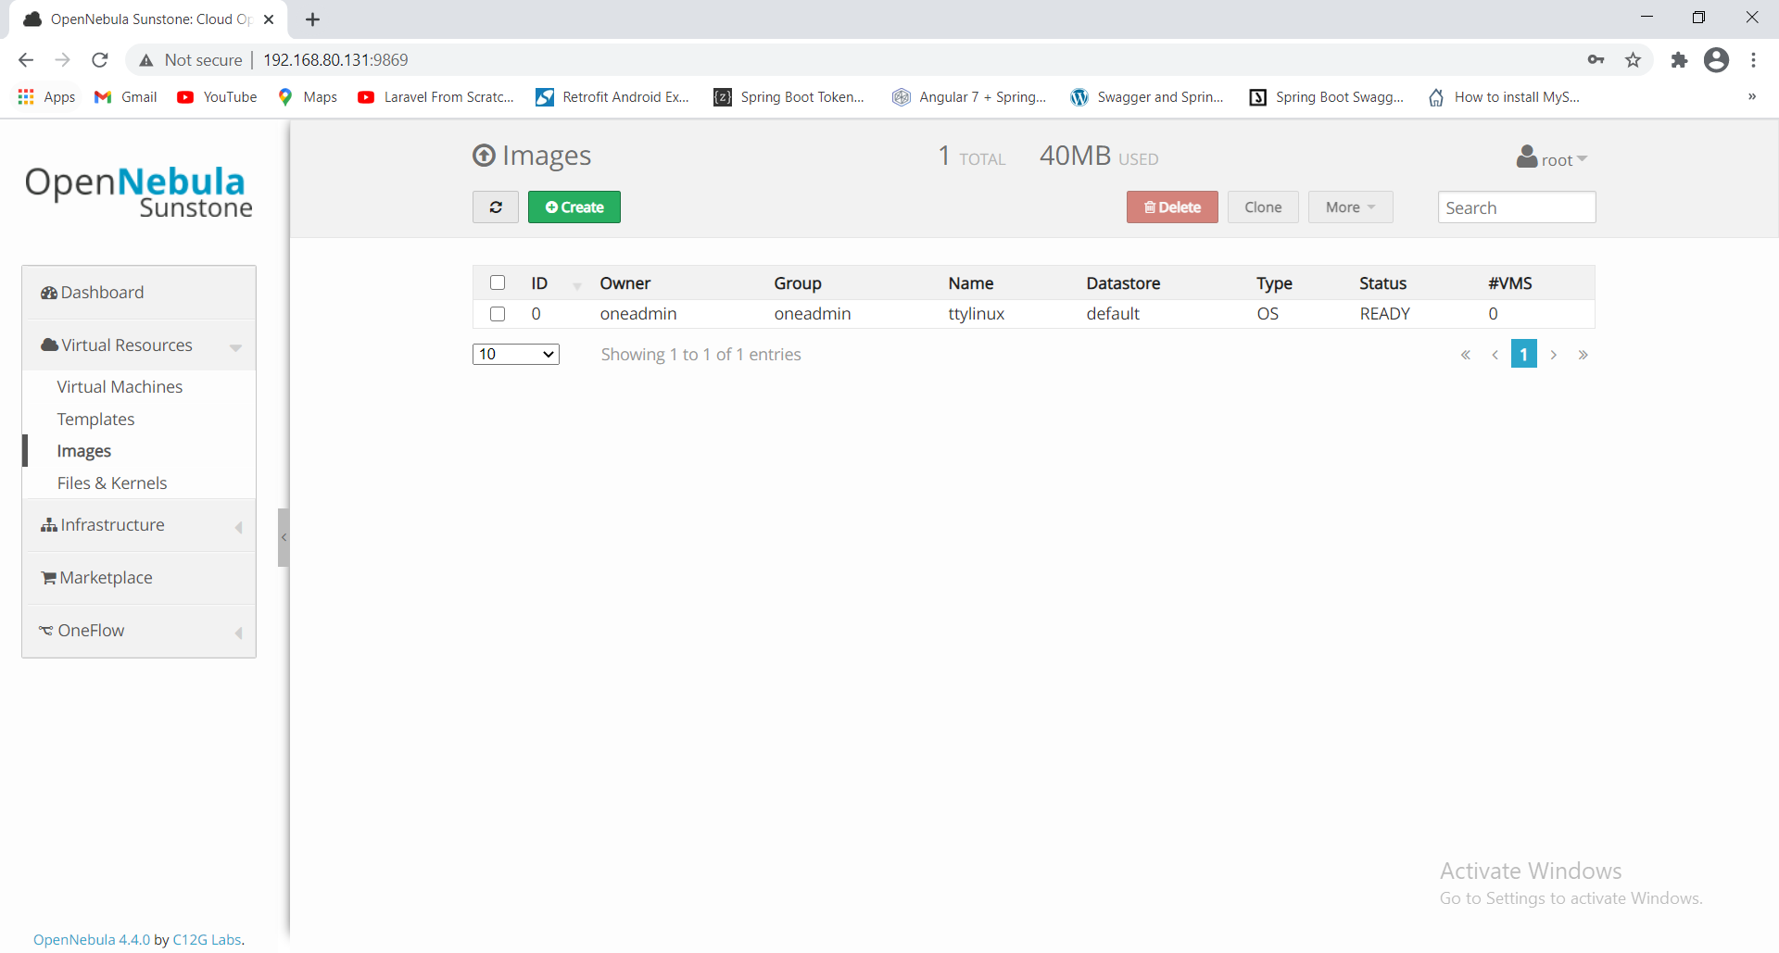

Change type: cdrom and Persistent : yes and upload the WindowsXP .iso file

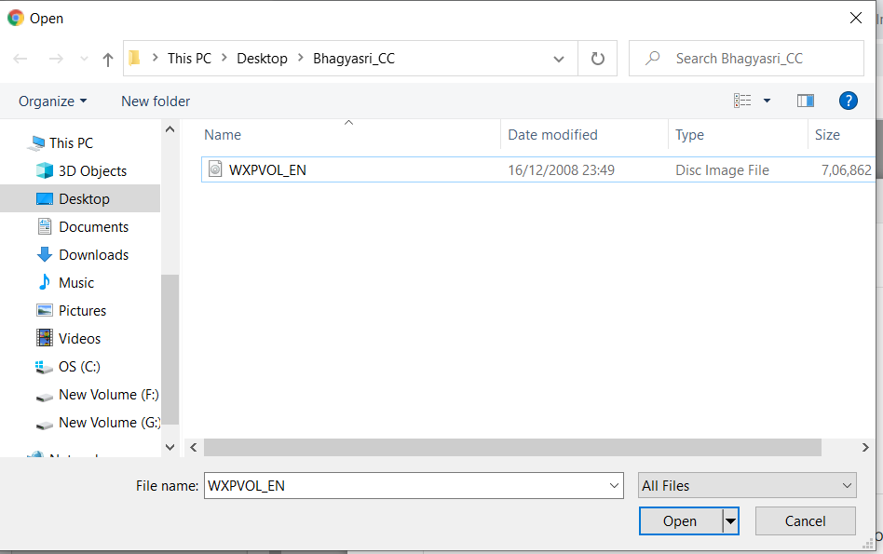

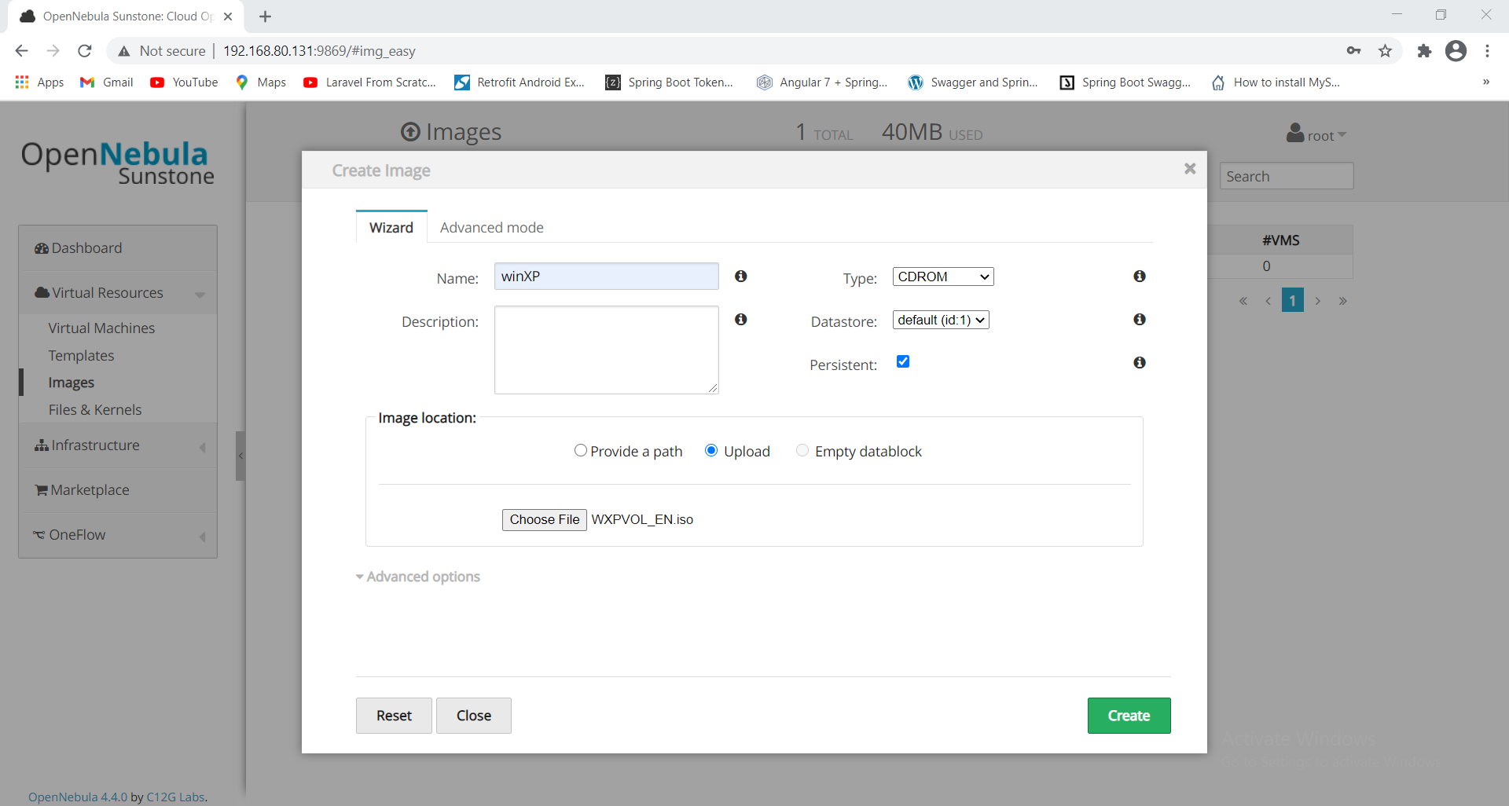

The image is getting uploaded

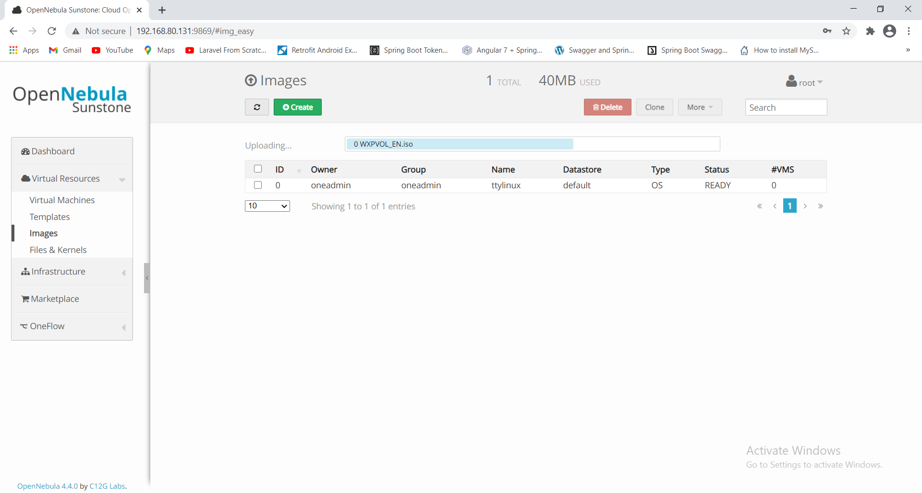

Image uploaded successfully

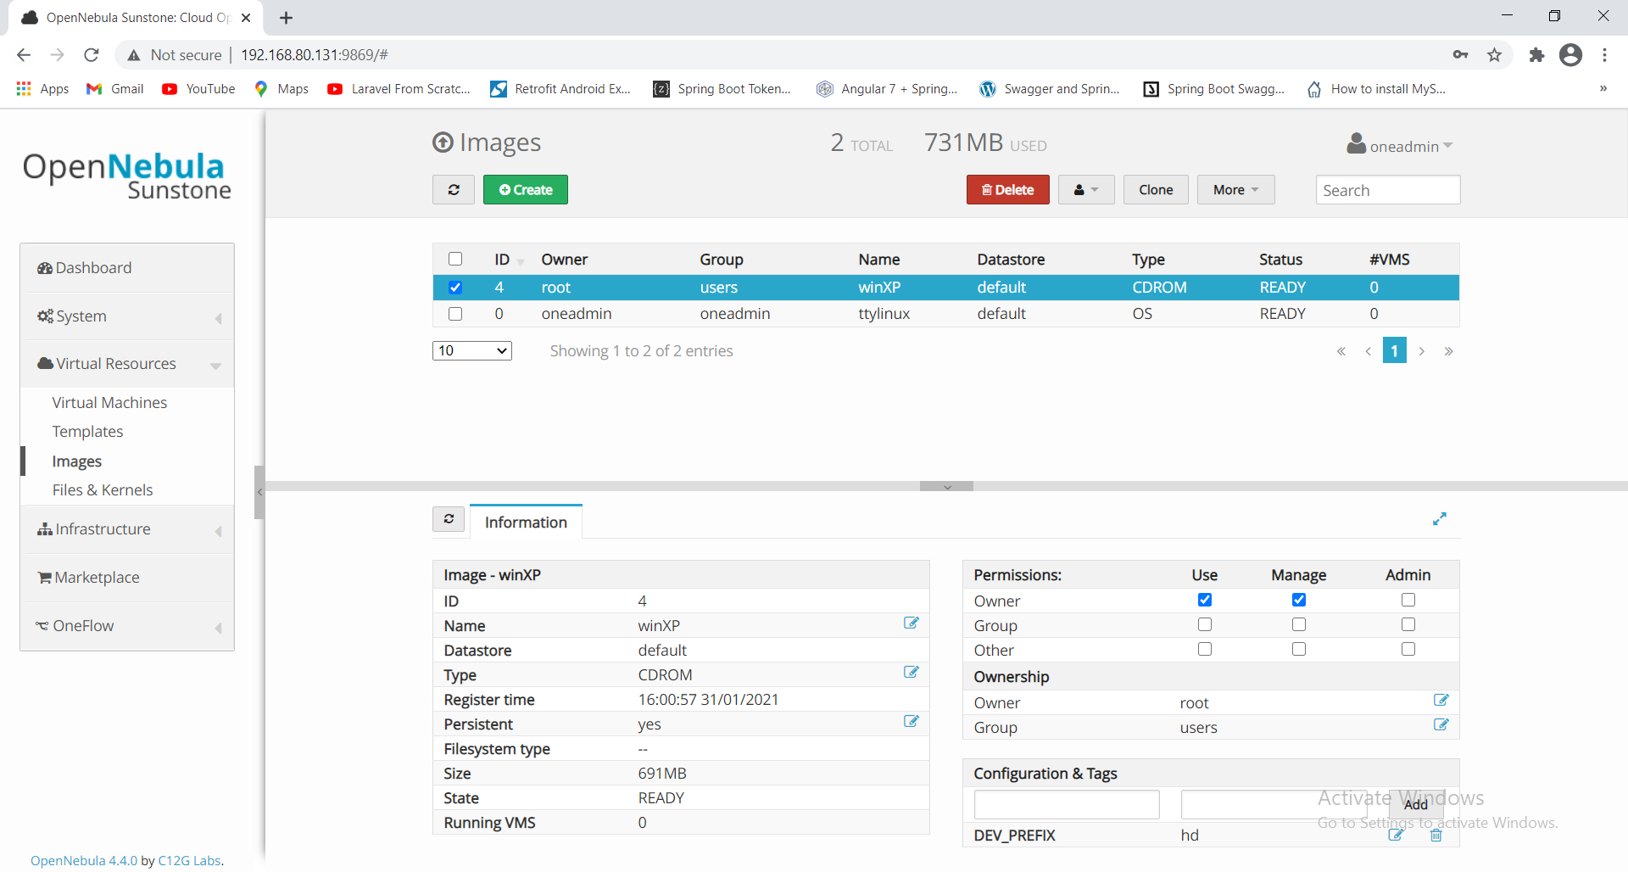

Now we will create Template.

click on "Virtual Resources" and templates

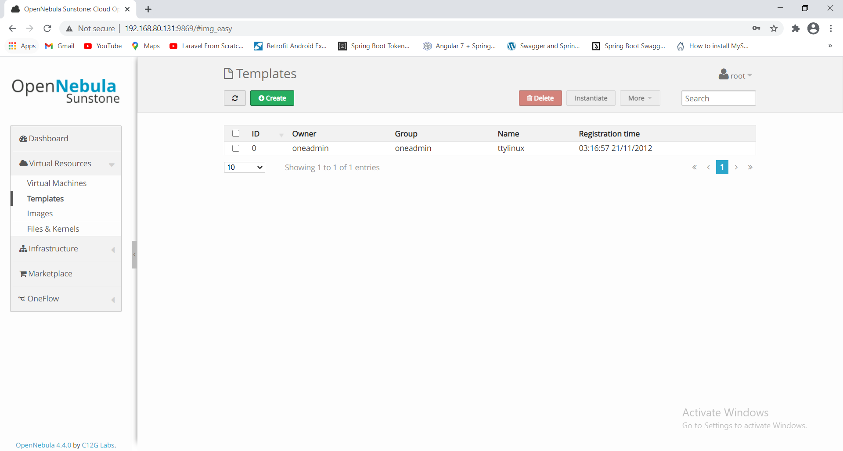

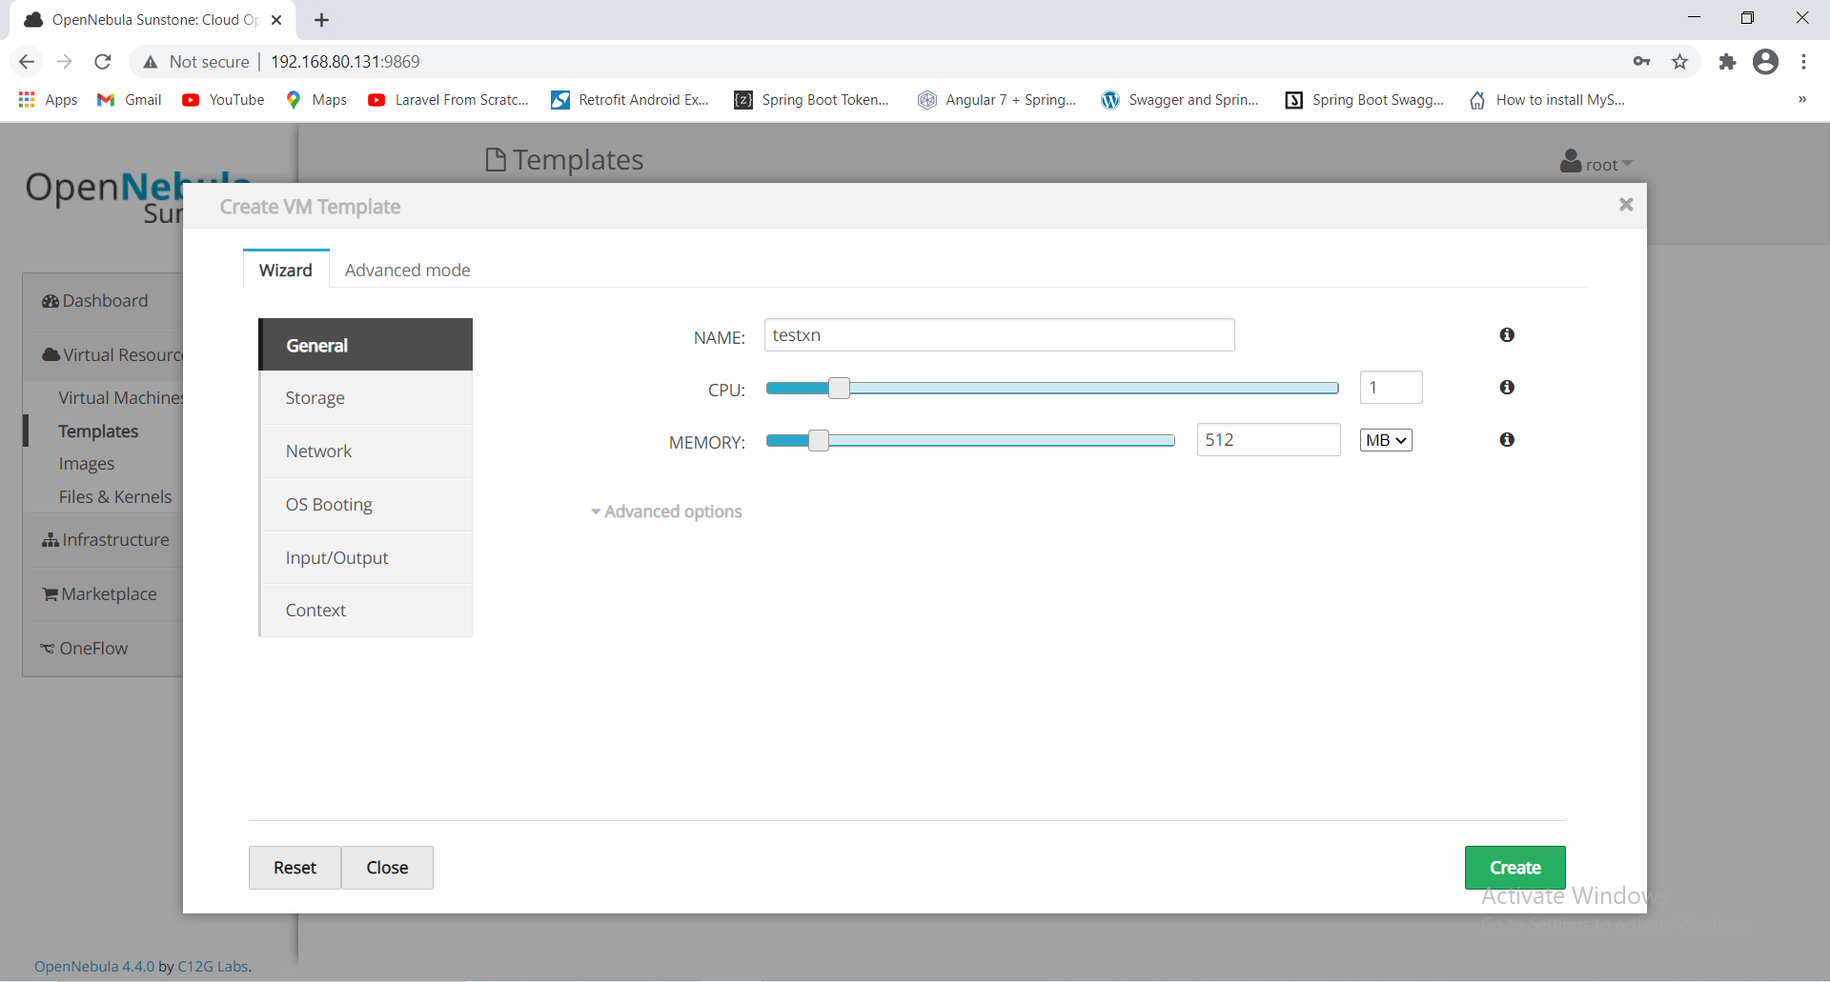

click on storage you will see the disk which is already added.

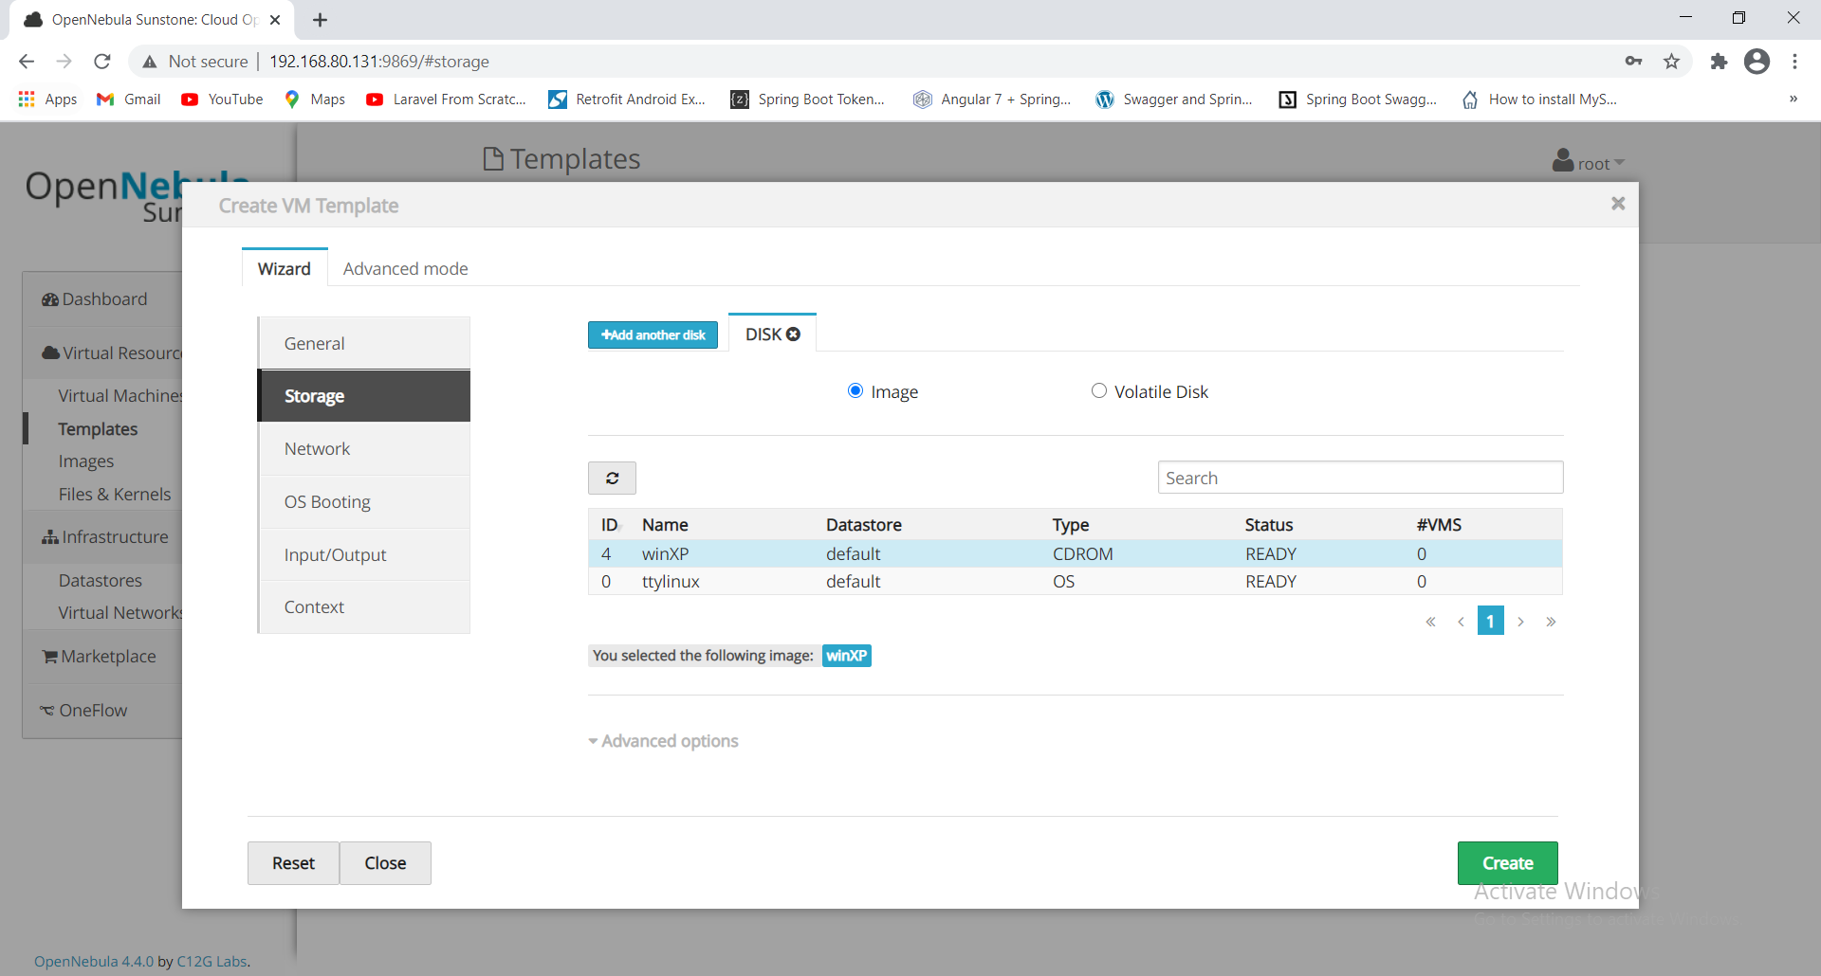

Click on Network , select the network local_test

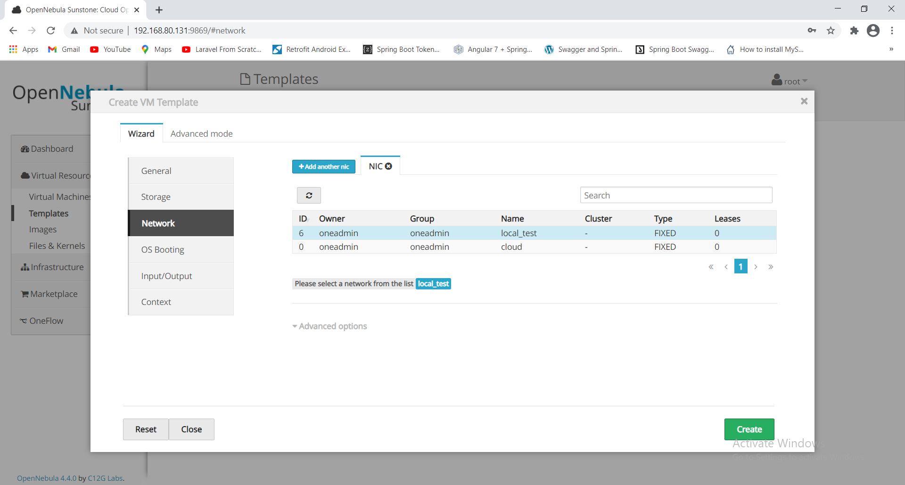

click on "OS Booting" and click Arch as **x86_64**,Boot as **CDROM** and GuestOS as **winXPHomeGuest**

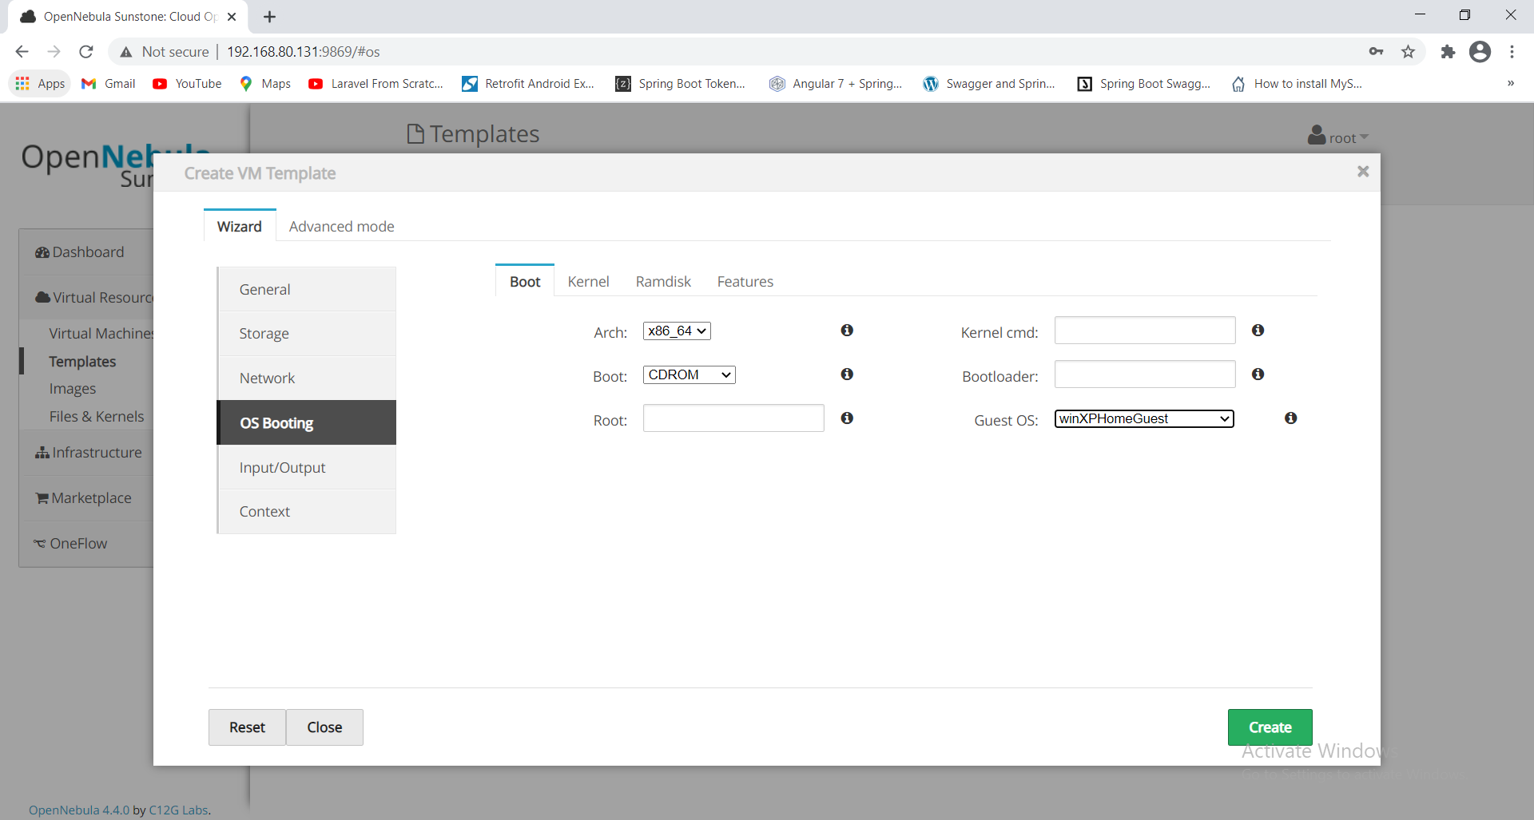

click on "INPUT/OUTPUT " SELECT "VNC" and keymap as “es”

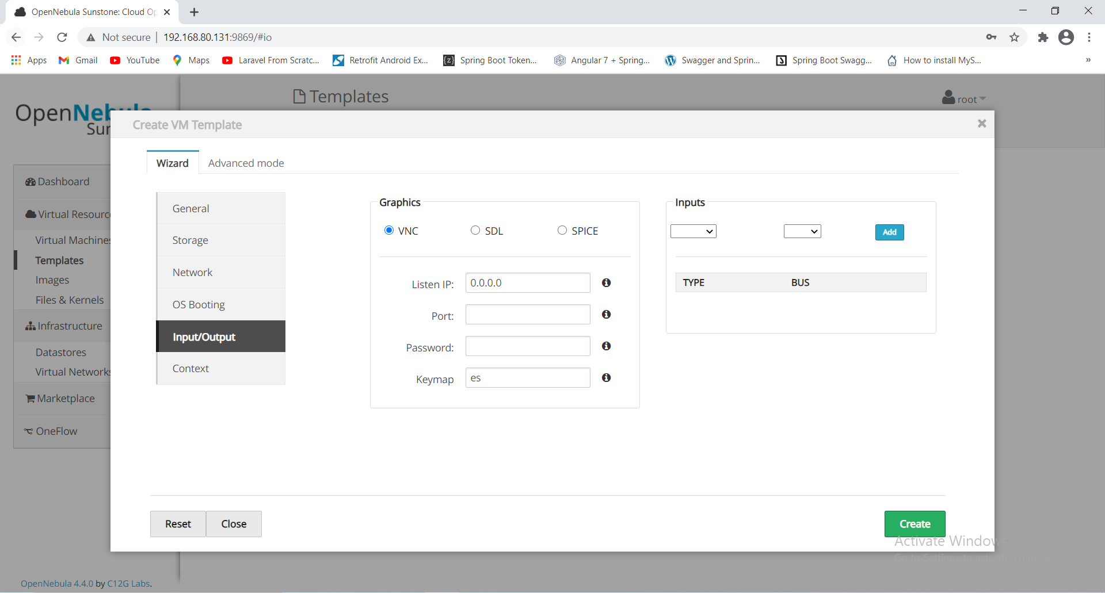

Click on Context and click on create.

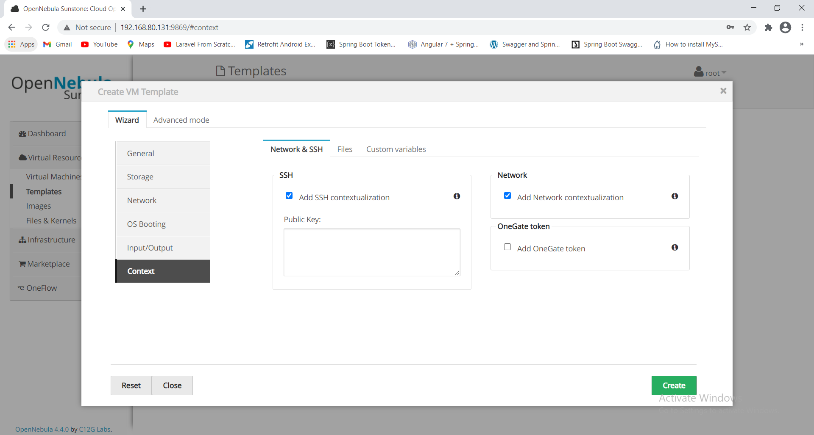

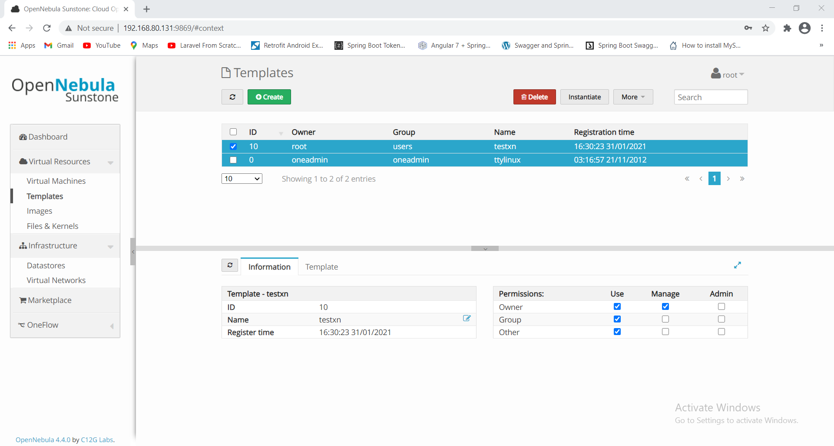

Click on Instantiate and give VM name as “WinXP_Test_12”

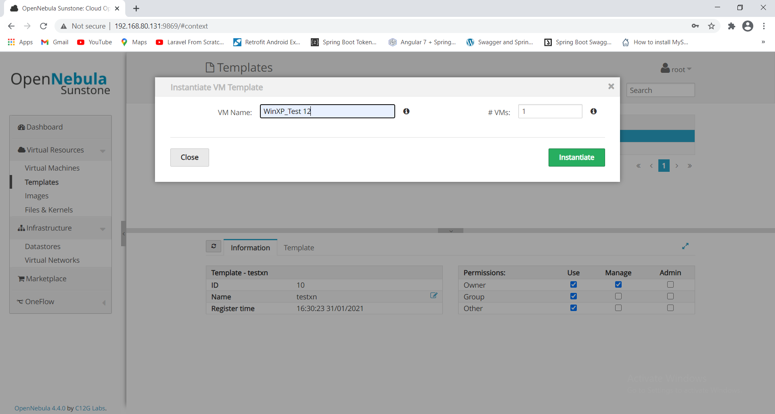

CLICK ON "VIRTUAL MACHINES"

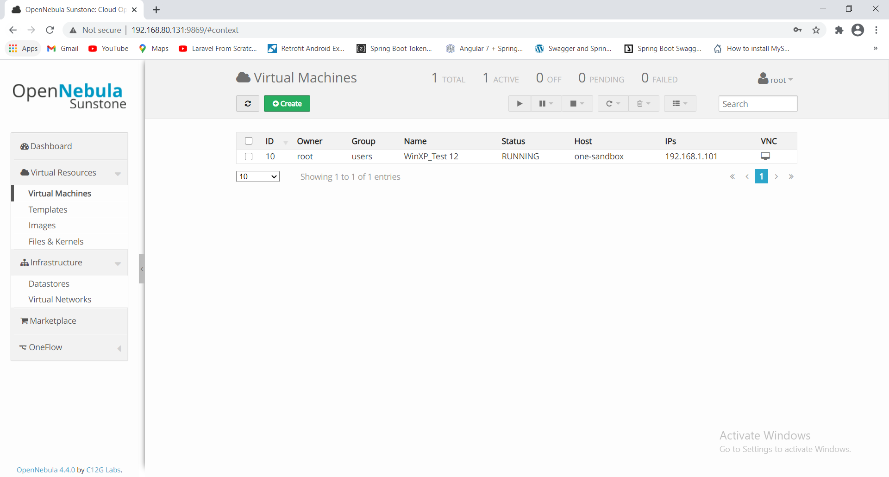

Click on VNC button you will see the below screen

